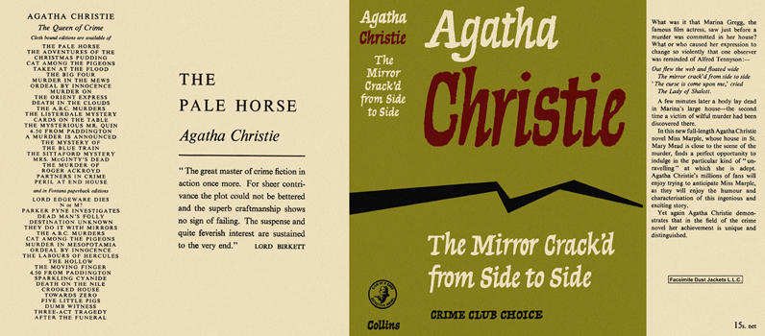

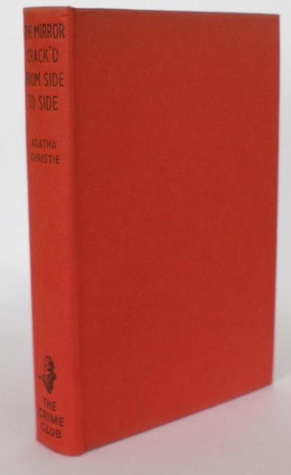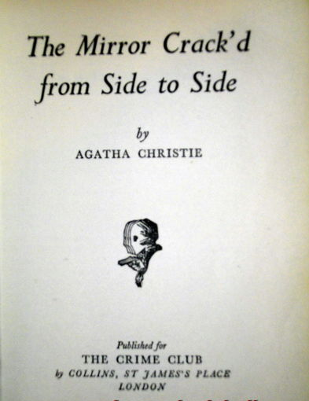

Christie, Agatha
The mirror crack'd from side to side
Collins The Crime Club (UK), 1962
first printing

Внешний вид первого издания романа

