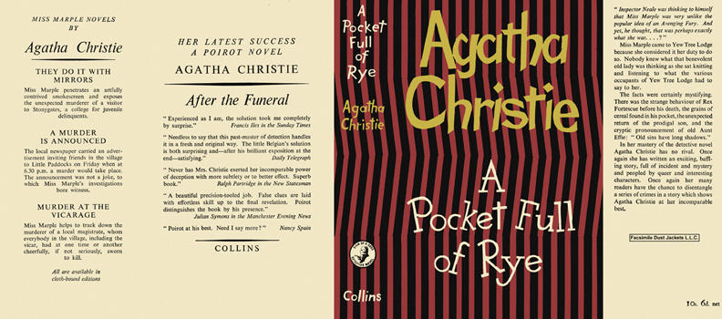

Christie, Agatha
A pocket full of rye
Collins The Crime Club (UK), 1953
first printing

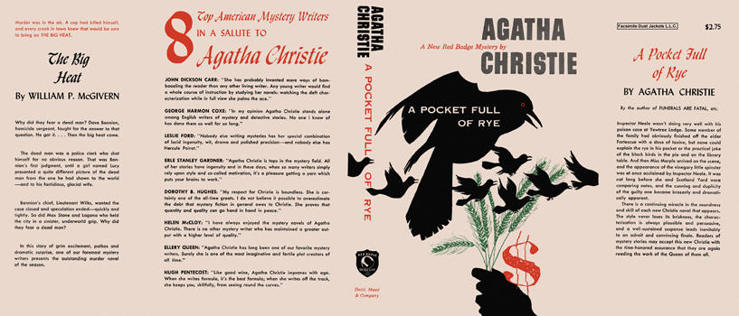

Christie, Agatha
A pocket full of rye
Dodd, Mead & Company (USA), 1953
first printing

Суперобложки первых изданий книги

