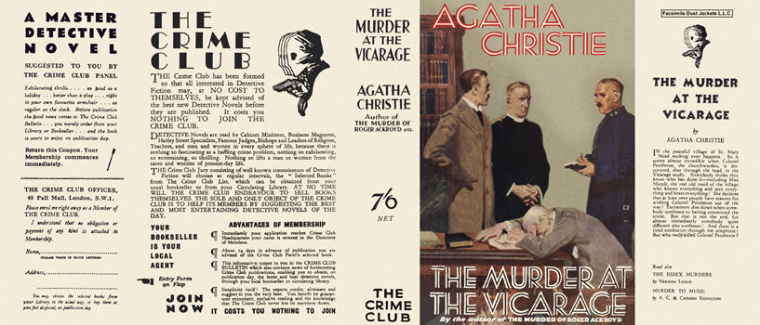
Christie, Agatha
The murder at the vicarage
Collins The Crime Club (UK), 1930
first printing

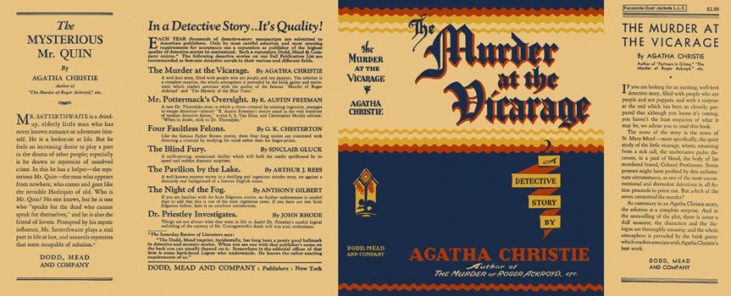
Christie, Agatha
The murder at the vicarage
Dodd, Mead & Company (USA), 1930
first printing

Суперобложки первых изданий книги

