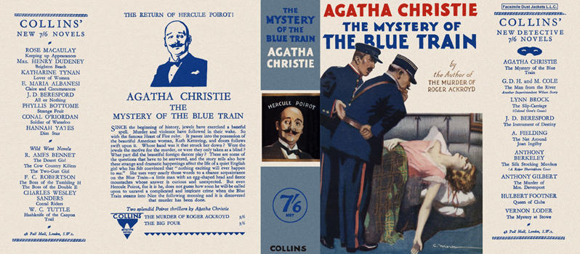

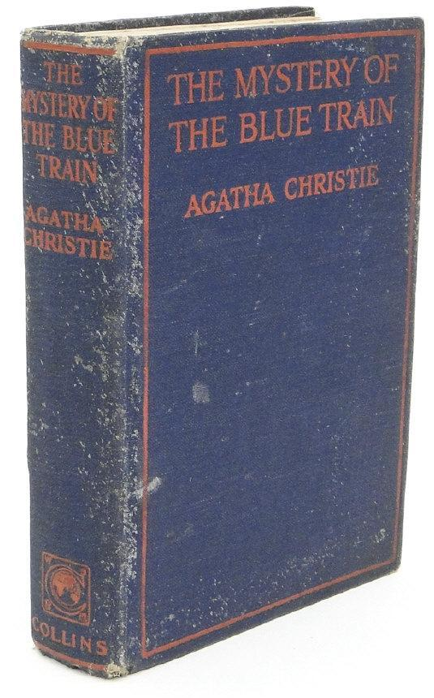

Christie, Agatha
The mystery of the blue train
Collins Detective Novel (UK), 1928
first printing

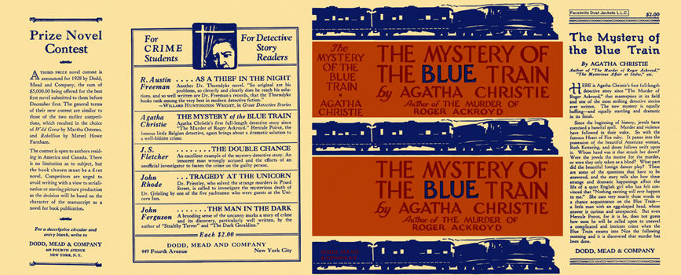

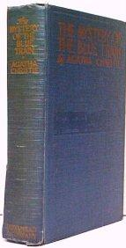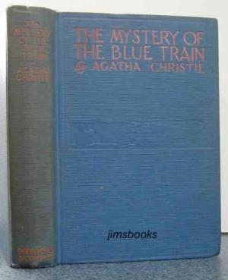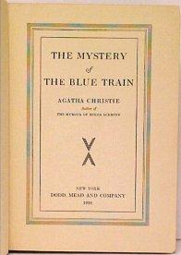

Christie, Agatha
The mystery of the blue train
Dodd, Mead & Company (USA), 1928
first printing

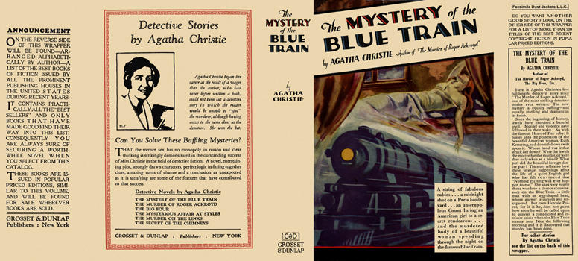

Christie, Agatha
The mystery of the blue train
Grosset & Dunlap (USA), 1928
first printing

Внешний вид первых изданий книги

