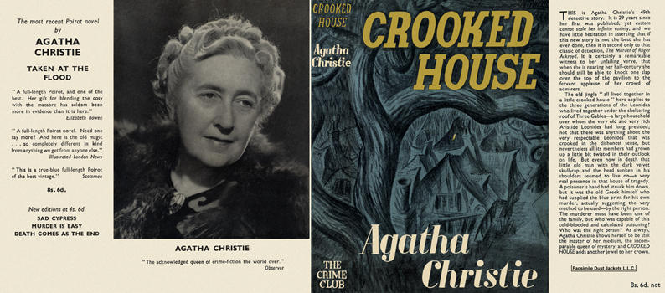

Christie, Agatha
Crooked house
Collins The Crime Club (UK), 1949
first printing

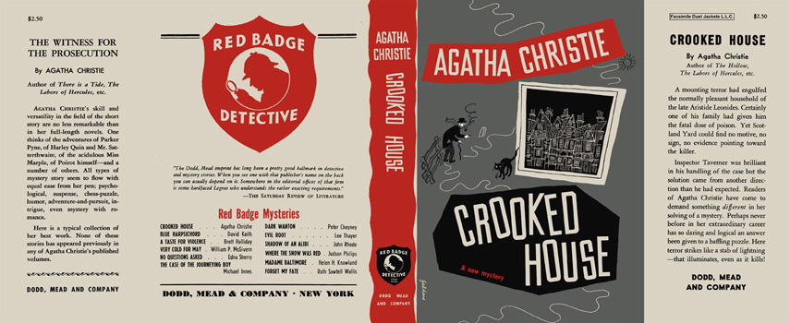

Christie, Agatha
Crooked house
Dodd, Mead and Company (USA), 1949
first printing

