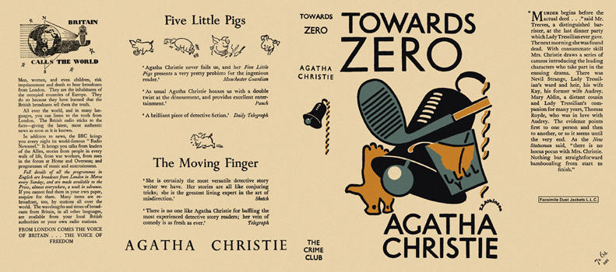

Christie, Agatha
Towards zero
Collins The Crime Club (UK), 1944
first printing

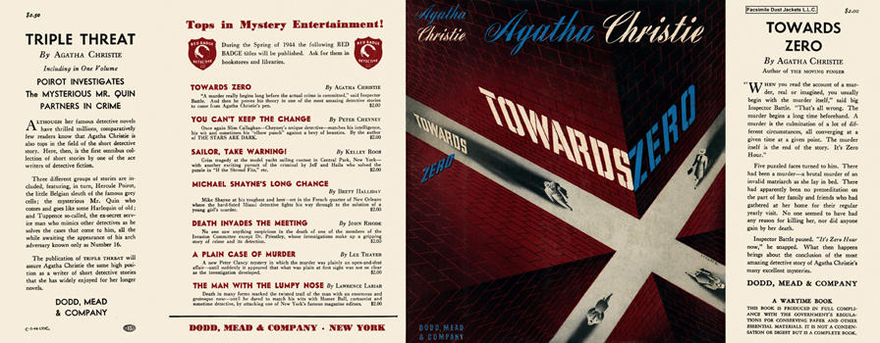

Christie, Agatha
Towards zero
Dodd, Mead & Company (USA), 1944
first printing

Суперобложки первых изданий книги

