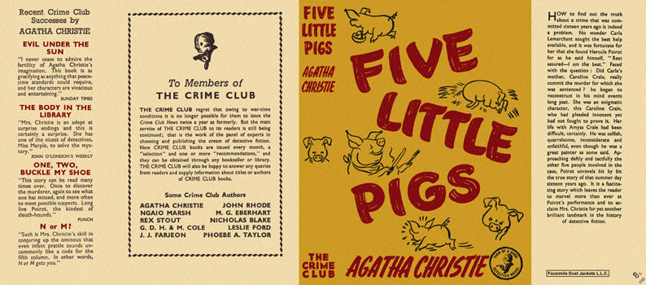

Christie, Agatha

Five little pigs
Collins The Crime Club (UK), 1943
first printing

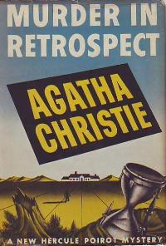

Christie, Agatha
Murder in retrospect
Dodd, Mead & Company (USA), 1942
first printing

Суперобложки первых изданий романа

