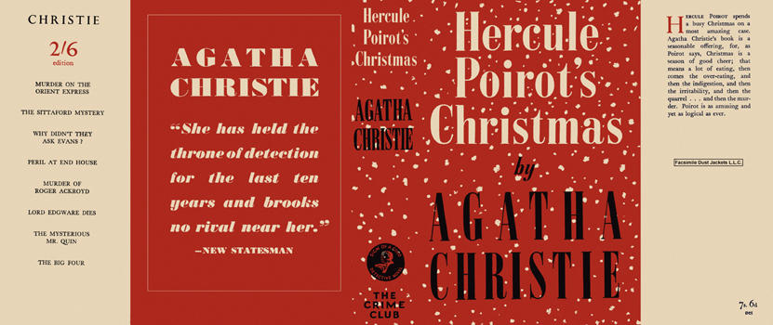

Christie, Agatha
Hercule Poirot Christmas
Collins The Crime Club (UK),1939
first printing

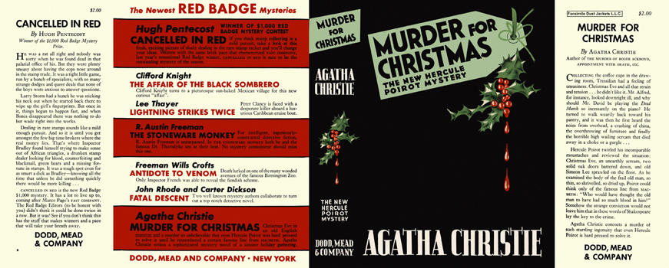

Christie, Agatha
Murder for Christmas
Dodd, Mead & Company (USA), 1939
first printing

Суперобложки первых изданий книги

