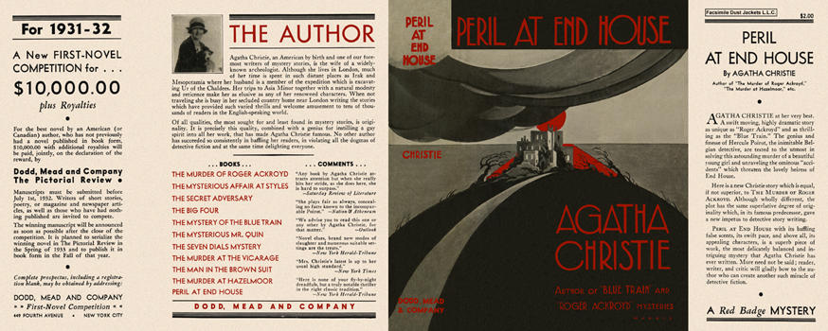

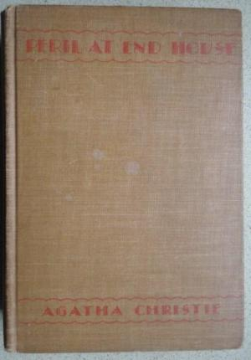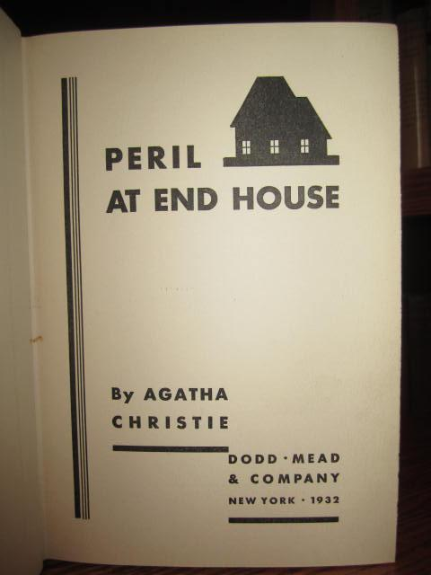

Christie, Agatha
Peril at End House
Dodd, Mead & Company (USA), 1932
first printing

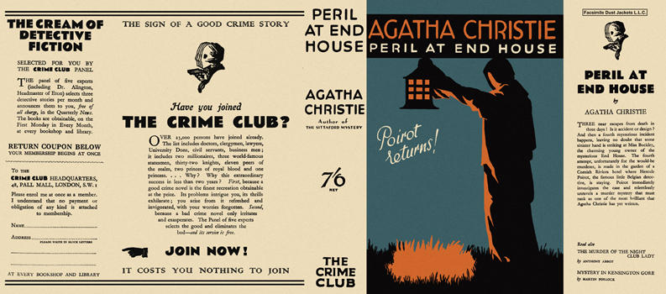

Christie, Agatha
Peril at End House
Collins The Crime Club (UK), 1932
first printing

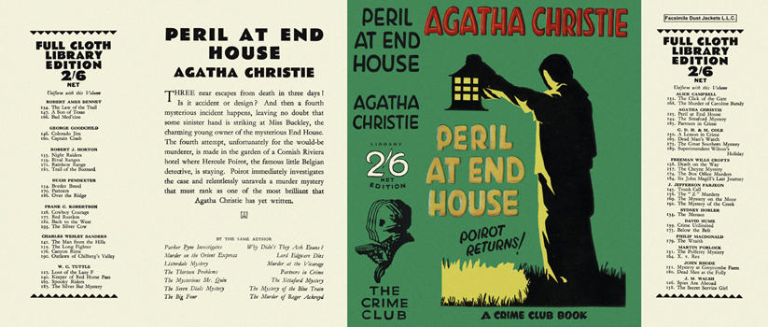

Christie, Agatha
Peril at End House
Collins The Crime Club (UK), 1932

Обложки первых изданий романа

