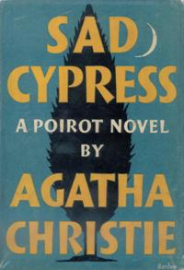

Dust-jacket illustration of the first UK edition

Christie A. Sad cypress. London: Collins crime club, 1940

