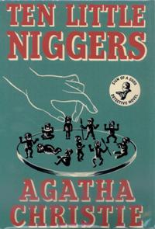

Cover of first UK edition

Christie A. Ten little Niggers. London: Collins crime club, 1939

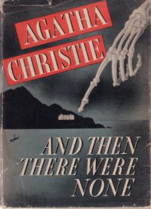

Cover of first US edition

Christie A. And then there were none. New York: Dodd, mead and company, 1940

