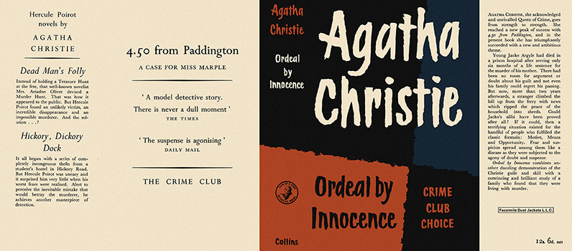

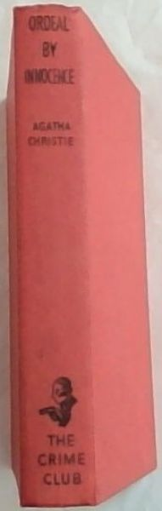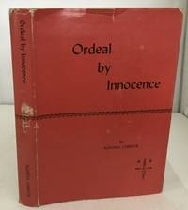

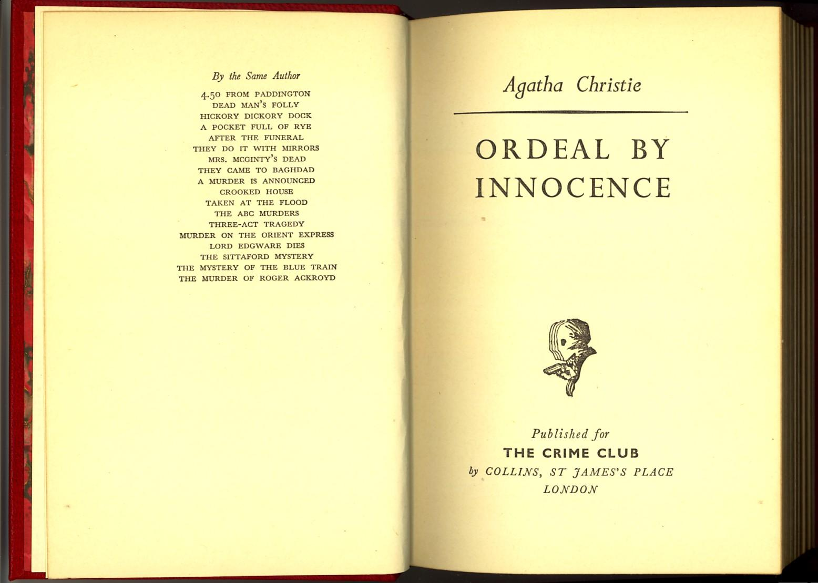

Christie, Agatha

Ordeal by innocence
Collins The Crime Club (UK) (1958) first printing.

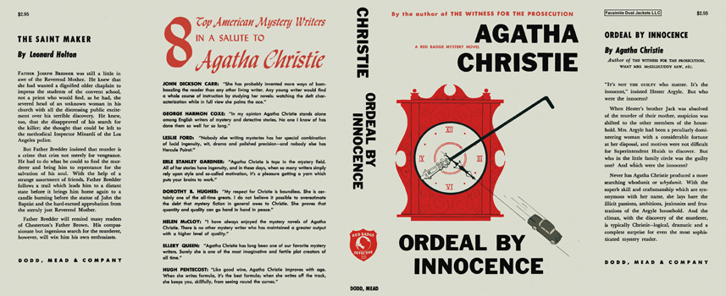

Christie, Agatha

Ordeal by innocence
Dodd, Mead & Company (USA) (1959) first printing

Суперобложки и внешний вид первых изданий книги

