

Christie, Agatha
Elephants can remember
Collins The Crime Club (UK) (1972) first printing

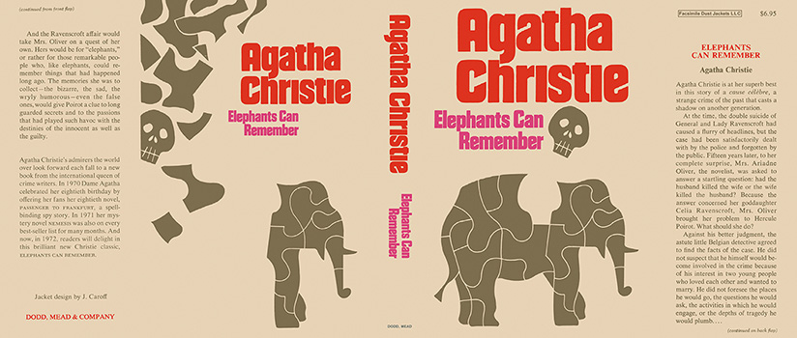

Christie, Agatha
Elephants can remember
Dodd, Mead & Company (USA) (1972) first printing

Суперобложки первых изданий книги

