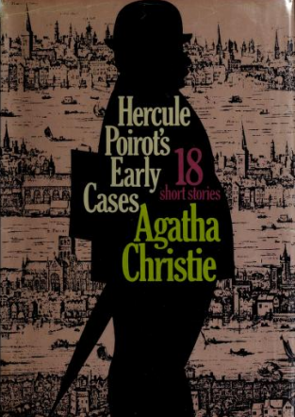

Agatha Christie
Hercule Poirot's early cases
N.Y.: Dodd, Mead and Company, 1974

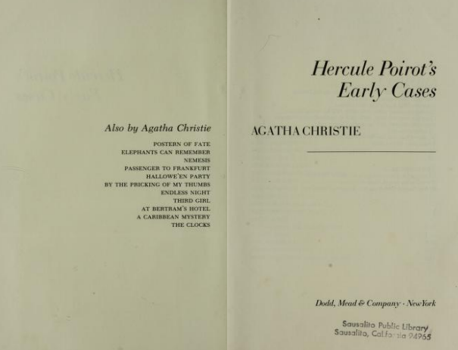

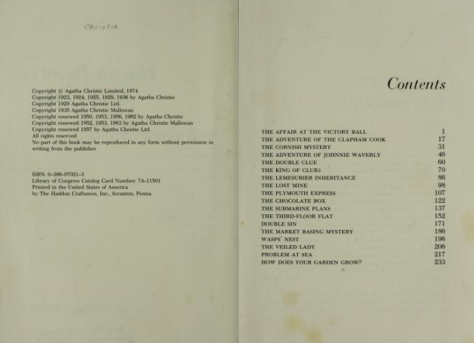

Agatha Christie

The Market Basing mystery

I

'After all, there's nothing like the country, is there?' said Inspector Japp, breathing in heavily through his nose and out through his mouth in the most approved fashion.
Poirot and I applauded the sentiment heartily. It had been the Scotland Yard inspector's idea that we should all go for the weekend to the little country town of Market Basing. When off duty, Japp was an ardent botanist, and discoursed upon minute flowers possessed of unbelievably lengthy Latin names (somewhat strangely pronounced) with an enthusiasm even greater than that he gave to his cases.
'Nobody knows us, and we know nobody,' explained Japp. 'That's the idea.'
This was not to prove quite the case, however, for the local constable happened to have been transferred from a village fifteen miles away where a case of arsenical poisoning had brought him into contact with the Scotland Yard man. However, his delighted recognition of the great man only enhanced Japp's sense of well-being, and as we sat down to breakfast on Sunday morning in the parlour of the village inn, with the sun shining, and tendrils of honeysuckle thrusting themselves in at the window, we were all in the best of spirits. The bacon and eggs were excellent, the coffee not so good, but passable and boiling hot.
'This is the life,' said Japp. 'When I retire, I shall have a little place in the country. Far from crime, like this!'
'Le crime, il est partout,' remarked Poirot, helping himself to a neat square of bread, and frowning at a sparrow which had balanced itself impertinently on the windowsill.
I quoted lightly:

'That rabbit has a pleasant face,
His private life is a disgrace
I really could not tell to you
The awful things that rabbits do.'

'Lord,' said Japp, stretching himself backward, 'I believe I could manage another egg, and perhaps a rasher or two of bacon. What do you say, Captain?'
'I'm with you,' I returned heartily. 'What about you, Poirot?'
Poirot shook his head.
'One must not so replenish the stomach that the brain refuses to function,' he remarked.
'I'll risk replenishing the stomach a bit more/ laughed Japp. 'I take a large size in stomachs; and by the way, you're getting stout yourself, M. Poirot. Here, miss, eggs and bacon twice.'
At that moment, however, an imposing form blocked the doorway. It was Constable Pollard.
'I hope you'll excuse me troubling the inspector, gentlemen, but I'd be glad of his advice.'
'I'm on holiday,' said Japp hastily. 'No work for me. What is the case?'
'Gentleman up at Leigh House — shot himself — through the head.'
'Well, they will do it,' said Japp prosaically. 'Debt, or a woman, I suppose. Sorry I can't help you, Pollard.'
'The point is,' said the constable, 'that he can't have shot himself. Leastways, that's what Dr Giles says.'
Japp put down his cup.
'Can't have shot himself? What do you mean?'
'That's what Dr Giles says,' repeated Pollard. 'He says it's plumb impossible. He's puzzled to death, the door being locked on the inside and the windows bolted; but he sticks to it that the man couldn't have committed suicide.'
That settled it. The further supply of bacon and eggs was waved aside, and a few minutes later we were all walking as fast as we could in the direction of Leigh House, Japp eagerly questioning the constable.
The name of the deceased was Walter Protheroe; he was a man of middle age and something of a recluse. He had come to Market Basing eight years ago and rented Leigh House, a rambling, dilapidated old mansion fast falling into ruin. He lived in a corner of it, his wants attended to by a housekeeper whom he had brought with him. Miss Clegg was her name, and she was a very superior woman and highly thought of in the village. Just lately Mr Protheroe had had visitors staying with him, a Mr and Mrs Parker from London. This morning, unable to get a reply when she went to call her master, and finding the door locked, Miss Clegg became alarmed, and telephoned for the police and the doctor. Constable Pollard and Dr Giles had arrived at the same moment. Their united efforts had succeeded in breaking down the oak door of his bedroom.
Mr Protheroe was lying on the floor, shot through the head, and the pistol was clasped in his right hand. It looked a clear case of suicide.
After examining the body, however, Dr Giles became clearly perplexed, and finally he drew the constable aside, and communicated his perplexities to him; whereupon Pollard had at once thought of Japp. Leaving the doctor in charge, he had hurried down to the inn.
By the time the constable's recital was over, we had arrived at Leigh House, a big, desolate house surrounded by an unkempt, weed-ridden garden. The front door was open, and we passed at once into the hall and from there into a small morning-room whence proceeded the sound of voices. Four people were in the room: a somewhat flashily dressed man with a shifty, unpleasant face to whom I took an immediate dislike; a woman of much the same type, though handsome in a coarse fashion; another woman dressed in neat black who stood apart from the rest, and whom I took to be the housekeeper; and a tall man dressed in sporting tweeds, with a clever, capable face, and who was clearly in command of the situation.
'Dr Giles,' said the constable, 'this is Detective-Inspector Japp of Scotland Yard, and his two friends.'
The doctor greeted us and made us known to Mr and Mrs Parker. Then we accompanied them upstairs. Pollard, in obedience to a sign from Japp, remained below, as it were on guard over the household. The doctor led us upstairs and along a passage. A door was open at the end; splinters hung from the hinges, and the door itself had crashed to the floor inside the room.
We went in. The body was still lying on the floor. Mr Protheroe had been a man of middle age, bearded, with hair grey at the temples. Japp went and knelt by the body.
'Why couldn't you leave it as you found it?' he grumbled.
The doctor shrugged his shoulders.
'We thought it a clear case of suicide.'
'H'mi' said Japp. 'Bullet entered the head behind the left ear.'
'Exactly,' said the doctor. 'Clearly impossible for him to have fired it himself. He'd have had to twist his hand right round his head. It couldn't have been done.'
'Yet you found the pistol clasped in his hand? Where is it, by the way?'
The doctor nodded to the table.
'But it wasn't clasped in his hand,' he said. 'It was inside the hand, but the fingers weren't closed over it.'
'Put there afterwards,' said Japp; 'that's clear enough.' He was examining the weapon. 'One cartridge fired. We'll test it for fingerprints, but I doubt if we'll find any but yours, Dr Giles. How long has he been dead?'
'Some time last night. I can't give the time to an hour or so, as those wonderful doctors in detective stories do. Roughly, he's been dead about twelve hours.'
So far, Poirot had not made a move of any kind. He had remained by my side, watching Japp at work and listening to his questions. Only, from time to time, he had sniffed the air very delicately, and as if puzzled. I too had sniffed, but could detect nothing to arouse interest. The air seemed perfectly fresh and devoid of odour. And yet, from time to time, Poirot continued to sniff it dubiously, as though his keener nose detected something I had missed.
Now, as Japp moved away from the body, Poirot knelt down by it. He took no interest in the wound. I thought at first that he was examining the fingers of the hand that had held the pistol, but in a minute I saw that it was a handkerchief carried in the coat-sleeve that interested him. Mr Protheroe was dressed in a dark grey lounge-suit. Finally Poirot got up from his knees, but his eyes still strayed back to the handkerchief as though puzzled.
Japp called to him to come and help to lift the door. Seizing my opportunity, I too knelt down, and taking the handkerchief from the sleeve, scrutinized it minutely. It was a perfectly plain handkerchief of white cambric; there was no mark or stain on it of any kind. I replaced it, shaking my head and confessing myself baffled.
The others had raised the door. I realized that they were hunting for the key. They looked in vain.
'That settles it,' said Japp. 'The window's shut and bolted. The murderer left by the door, locking it and taking the key with him. He thought it would be accepted that Protheroe had locked himself in and shot himself, and that the absence of the key would not be noticed. You agree, M. Poirot?'
'I agree, yes; but it would have been simpler and better to slip the key back inside the room under the door. Then it would look as though it had fallen from the lock.'
'Ah, well, you can't expect everybody to have the bright ideas that you have. You'd have been a holy terror if you'd taken to crime. Any remarks to make, M. Poirot?'
Poirot, it seemed to me, was somewhat at a loss. He looked round the room and remarked mildly and almost apologetically: 'He smoked a lot, this monsieur.'
True enough, the grate was filled with cigarette-stubs, as was an ashtray that stood on a small table near the big armchair.
'He must have got through about twenty cigarettes last night,' remarked Japp. Stooping down, he examined the contents of the grate carefully, then transferred his attention to the ashtray. 'They're all the same kind,' he announced, 'and smoked by the same man. There's nothing there, M. Poirot.'
'I did not suggest that there was,' murmured my friend.
'Ha,' cried Japp, 'what's this?' He pounced on something bright and glittering that lay on the floor near the dead man. 'A broken cuff-link. I wonder who this belongs to. Dr Giles, I'd be obliged if you'd go down and send up the housekeeper.'
'What about the Parkers? He's very anxious to leave the house— says he's got urgent business in London.'
'I dare say. It'll have to get on without him. By the way things are going, it's likely that there'll be some urgent business down here for him to attend to! Send up the housekeeper, and don't let either of the Parkers give you and Pollard the slip. Did any of the household come in here this morning?'
The doctor reflected.
'No, they stood outside in the corridor while Pollard and I came in.'
'Sure of that?'
'Absolutely certain.'
The doctor departed on his mission.
'Good man, that,' said Japp approvingly. 'Some of these sporting doctors are first-class fellows. Well, I wonder who shot this chap. It looks like one of the three in the house. I hardly suspect the housekeeper. She's had eight years to shoot him in if she wanted to. I wonder who these Parkers are? They're not a prepossessing-looking couple.'
Miss Clegg appeared at this juncture. She was a thin, gaunt woman with neat grey hair parted in the middle, very staid and calm in manner. Nevertheless there was an air of efficiency about her which commanded respect. In answer to Japp's questions, she explained that she had been with the dead man for fourteen years. He had been a generous and considerate master. She had never seen Mr and Mrs Parker until three days ago, when they arrived unexpectedly to stay. She was of the opinion that they had asked themselves — the master had certainly not seemed pleased to see them. The cuff-links which Japp showed her had not belonged to Mr Protheroe — she was sure of that.
Questioned about the pistol, she said that she believed her master had a weapon of that kind. He kept it locked up. She had seen it once some years ago, but could not say whether this was the same one. She had heard no shot last night, but that was not surprising, as it was a big, rambling house, and her rooms and those prepared for the Parkers were at the other end of the building. She did not know what time Mr Protheroe had gone to bed — he was still up when she retired at half past nine. It was not his habit to go at once to bed when he went to his room. Usually he would sit up half the night, reading and smoking. He was a great smoker.
Then Poirot interposed a question: 'Did your master sleep with his window open or shut, as a rule?'
Miss Clegg considered.
'It was usually open, at any rate at the top.'
'Yet now it is closed. Can you explain that?'
'No, unless he felt a draught and shut it.'
Japp asked her a few more questions and then dismissed her. Next he interviewed the Parkers separately. Mrs Parker was inclined to be hysterical and tearful; Mr Parker was full of bluster and abuse. He denied that the cuff-link was his, but as his wife had previously recognized it, this hardly improved matters for him; and as he had also denied ever having been in Protheroe's room, Japp considered that he had sufficient evidence to apply for a warrant.
Leaving Pollard in charge, Japp bustled back to the village and got into telephonic communication with headquarters. Poirot and I strolled back to the inn.
'You're unusually quiet,' I said. 'Doesn't the case interest you?'
'Au contraire, it interests me enormously. But it puzzles me also.'
'The motive is obscure,' I said thoughtfully, 'but I'm certain that Parker's a bad lot. The case against him seems pretty clear but for the lack of motive, and that may come out later.'
'Nothing struck you as being especially significant, although overlooked by Japp?'
I looked at him curiously.
'What have you got up your sleeve, Poirot?'
'What did the dead man have up his sleeve?'
'Oh, that handkerchief!'
'Exactly, that handkerchief.'
'A sailor carries his handkerchief in his sleeve,' I said thoughtfully.
'An excellent point, Hastings, though not the one I had in mind.'
'Anything else?'
'Yes, over and over again I go back to the smell of cigarette-smoke.'
'I didn't smell any,' I cried wonderingly.
'No more did I, cher ami.'
I looked earnestly at him.
It is so difficult to know when Poirot is pulling one's leg, but he seemed thoroughly in earnest and was frowning to himself.

II

The inquest took place two days later. In the meantime other evidence had come to light. A tramp had admitted that he had climbed over the wall into the Leigh House garden, where he often slept in a shed that was left unlocked. He declared that at twelve o'clock he had heard two men quarrelling loudly in a room on the first floor. One was demanding a sum of money; the other was angrily refusing. Concealed behind a bush, he had seen the two men as they passed and repassed the lighted window. One he knew well as being Mr Protheroe, the owner of the house; the other he identified positively as Mr Parker.
It was clear now that the Parkers had come to Leigh House to blackmail Protheroe, and when later it was discovered that the dead man's real name was Wendover, and that he had been a lieutenant in the Navy and had been concerned in the blowing up of the first-class cruiser Merrythought, in 1910, the case seemed to be rapidly clearing. It was supposed that Parker, cognizant of the part Wendover had played, had tracked him down and demanded hush-money which the other refused to pay. In the course of the quarrel, Wendover drew his revolver, and Parker snatched it from him and shot him, subsequently endeavouring to give it the appearance of suicide.
Parker was committed for trial, reserving his defence. We had attended the police-court proceedings. As we left, Poirot nodded his head.
'It must be so,' he murmured to himself. 'Yes, it must be so. I will delay no longer.'
He went into the post office, and wrote off a note which he despatched by special messenger. I did not see to whom it was addressed. Then we returned to the inn where we had stayed on that memorable weekend.
Poirot was restless, going to and from the window.
'I await a visitor,' he explained. 'It cannot be— surely it cannot be that I am mistaken? No, here she is.'
To my utter astonishment, in another minute Miss Clegg walked into the room. She was less calm than usual, and was breathing hard as though she had been running. I saw the fear in her eyes as she looked at Poirot.
'Sit down, mademoiselle,' he said kindly. 'I guessed rightly, did I not?'
For answer she burst into tears.
'Why did you do it?' asked Poirot gently. 'Why?'
'I loved him so,' she answered. 'I was nursemaid to him when he was a little boy. Oh, be merciful to me!'
'I will do all I can. But you understand that I cannot permit an innocent man to hang — even though he is an unpleasing scoundrel.'
She sat up and said in a low voice: 'Perhaps in the end I could not have, either. Do whatever must be done.'
Then, rising, she hurried from the room.
'Did she shoot him?' I asked utterly bewildered.
Poirot smiled and shook his head.
'He shot himself. Do you remember that he carried his handkerchief in his right sleeve? That showed me that he was left-handed. Fearing exposure, after his stormy interview with Mr Parker, he shot himself. In the morning Miss Clegg came to call him as usual and found him lying dead. As she has just told us, she had known him from a little boy upward, and was filled with fury against the Parkers, who had driven him to this shameful death. She regarded them as murderers, and then suddenly she saw a chance of making them suffer for the deed they had inspired. She alone knew that he was left-handed. She changed the pistol to his right hand, closed and bolted the window, dropped the bit of cuff-link she had picked up in one of the downstairs rooms, and went out, locking the door and removing the key.'
'Poirot,' I said, in a burst of enthusiasm, 'you are magnificent. All that from the one little clue of the handkerchief.'
'And the cigarette-smoke. If the window had been closed, and all those cigarettes smoked, the room ought to have been full of stale tobacco. Instead, it was perfectly fresh, so I deduced at once that the window must have been open all night, and only closed in the morning, and that gave me a very interesting line of speculation. I could conceive of no circumstances under which a murderer could want to shut the window. It would be to his advantage to leave it open, and pretend that the murderer had escaped that way, if the theory of suicide did not go down. Of course, the tramp's evidence, when I heard it, confirmed my suspicions. He could never have overheard that conversation unless the window had been open.'
'Splendid!' I said heartily. 'Now, what about some tea?'
'Spoken like a true Englishman,' said Poirot with a sigh. 'I suppose it is not likely that I could obtain here a glass of sirop?'

