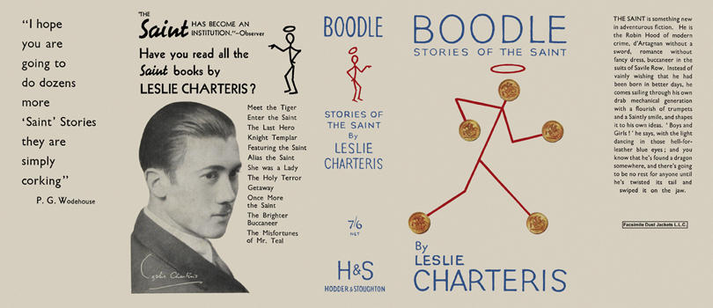
Charteris, Leslie

Boodle, Stories of the Saint
Hodder and Stoughton (UK) (1934) first printing

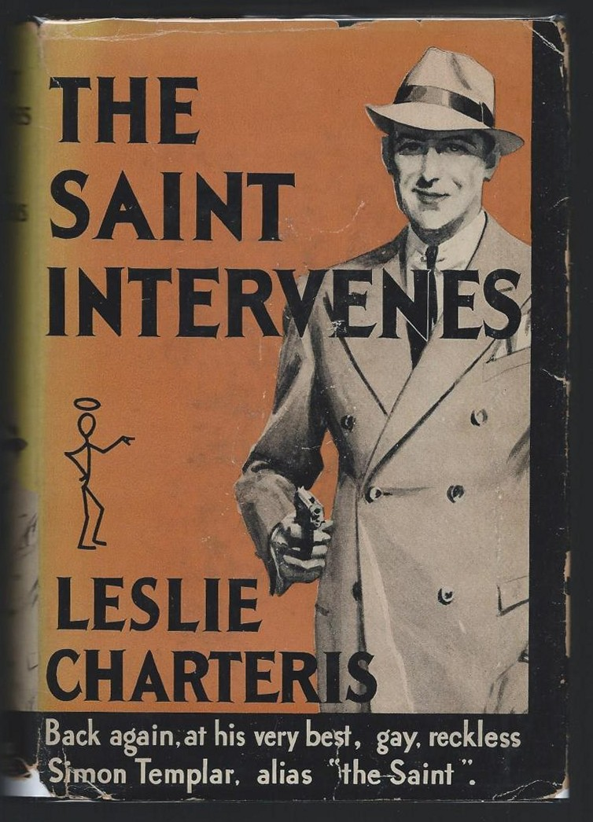
Charteris, Leslie

The Saint intervenes
Doubleday / Crime Club, New York (USA) (1934) first printing

Суперобложки первых изданий книги

