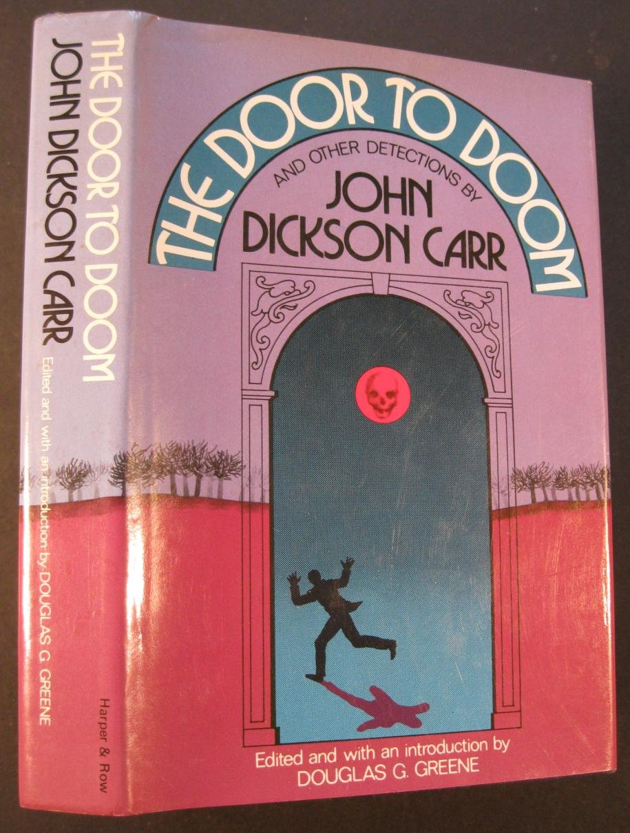

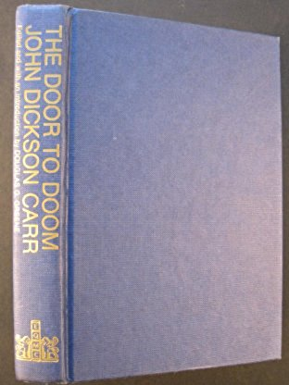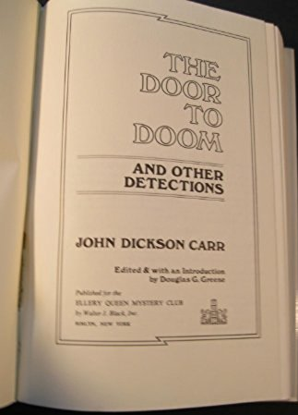

John Dixon Carr

The door to doom and other detections

Published by Ellery Queen mystery club

New York: Harper and Row publishers Inc., 1980

Внешний вид книги, в которой была напечатана Cabin B-13

