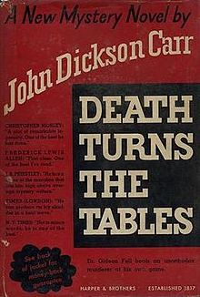

First US edition

Carr J.D. Death turns the tables. New York: Harper and brothers, 1941



First UK edition

Carr J.D. The seat of the scornful. London: Hamish Hamilton, 1942

