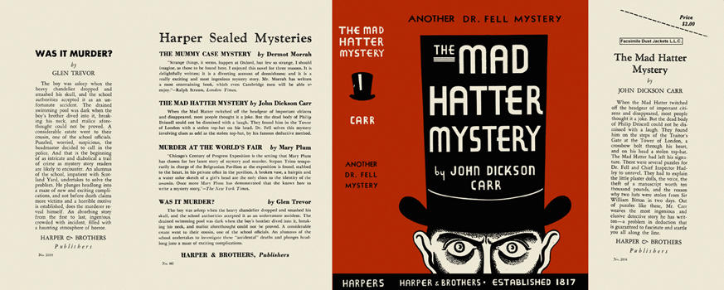

First US edition

Carr J.D. The Mad Hatter mystery. New York: Harper and brothers, 1933

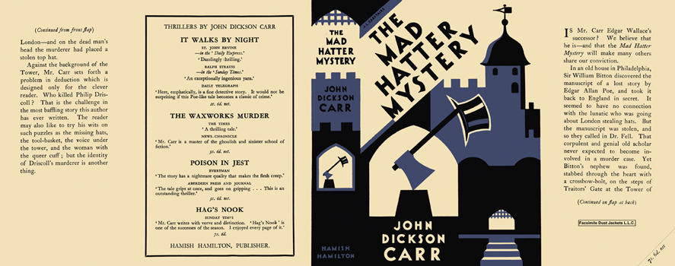

First UK edition

Carr J.D. The Mad Hatter mystery. London: Hamish Hamilton, 1933

