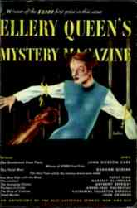

The Gentleman from Paris

By John Dickson Carr

// Ellery Queen's mystery magazine, April 1950, p. 9-30

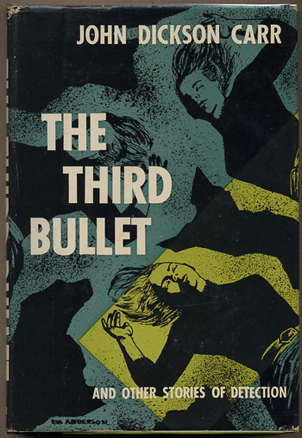

Carr, John Dickson.
THE THIRD BULLET AND OTHER STORIES.
New York: Harper & Brothers, [1954]. First edition.
Collects the title novella and six short stories originally published between 1942 and 1954.
- The Third Bullet (1937)
- Strictly Diplomatic (1939)
- The Locked Room (1940)
- The Clue of the Red Wig (1940)
- The House in Goblin Wood (1947)
- The Gentleman from Paris (1950)

