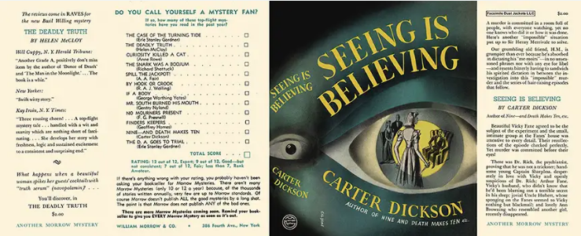

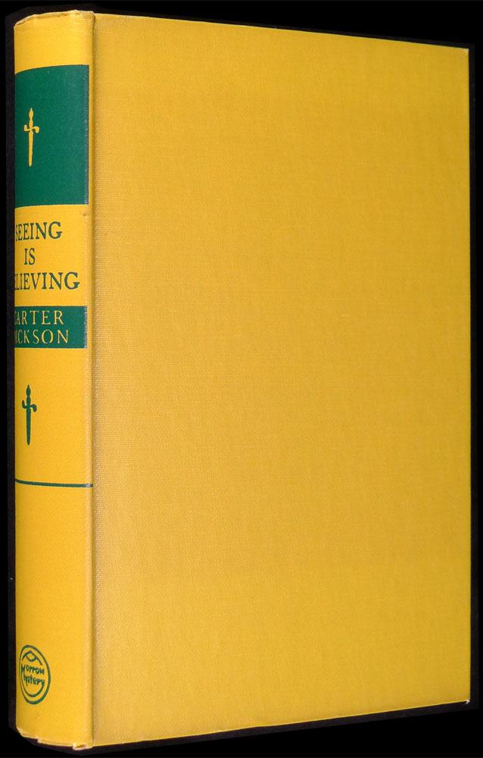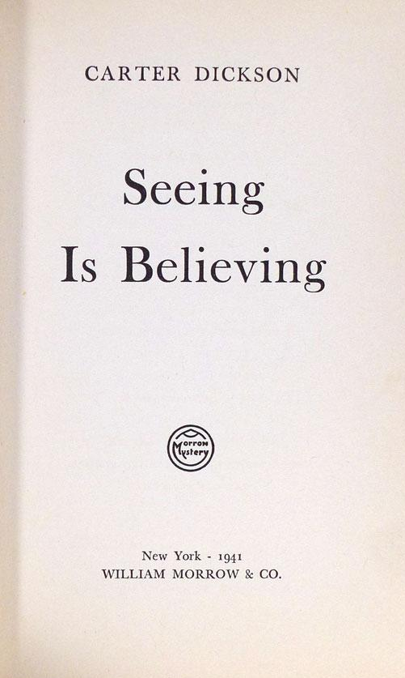

Dickson, Carter
Seeing is believing
Morrow Mystery (USA) (1941) first printing

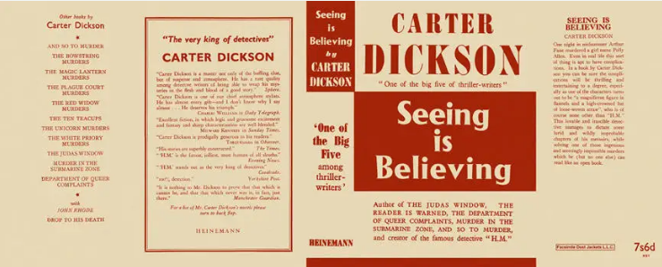

Dickson, Carter
Seeing is believing
Heinemann (UK) (1942) first printing

Суперобложки и внешний вид первых изданий романа

