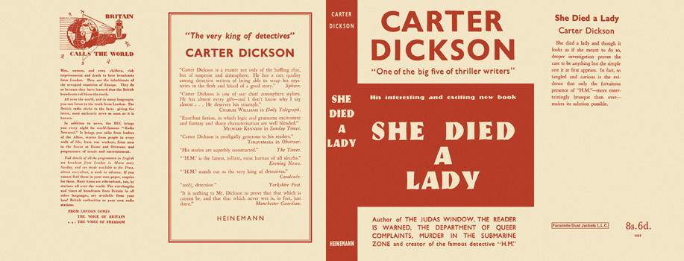

Dickson, Carter
She died a Lady
Heinemann (UK) (1943) first printing.

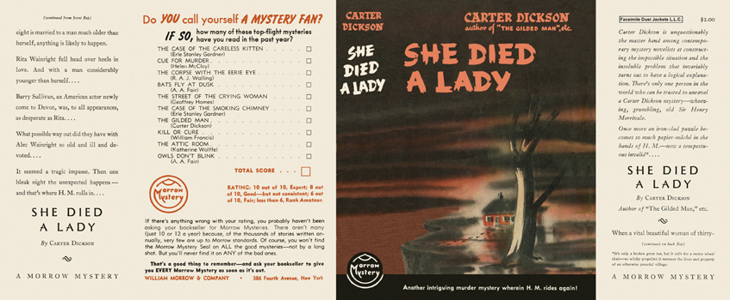

Dickson, Carter
She died a Lady
Morrow Mystery (USA) (1943) first printing

Суперобложки первых изданий книги

