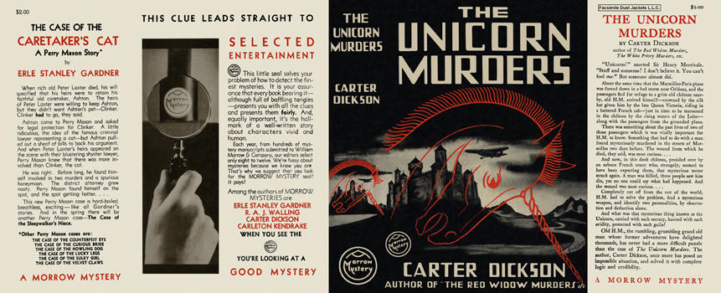

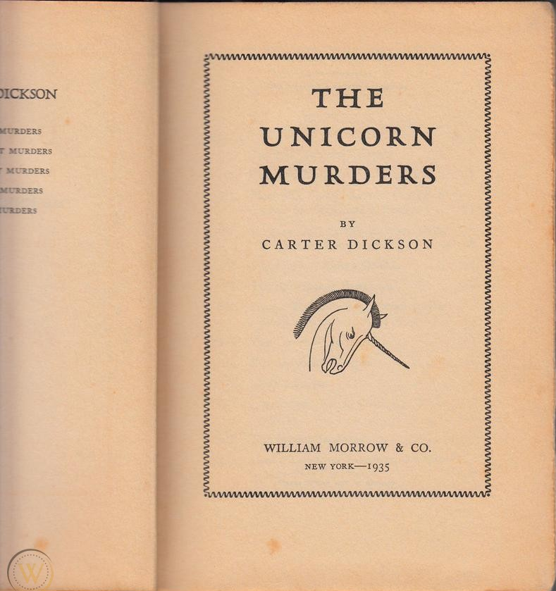

Dickson, Carter

The unicorn murders
Morrow Mystery (USA) (1935) first printing.

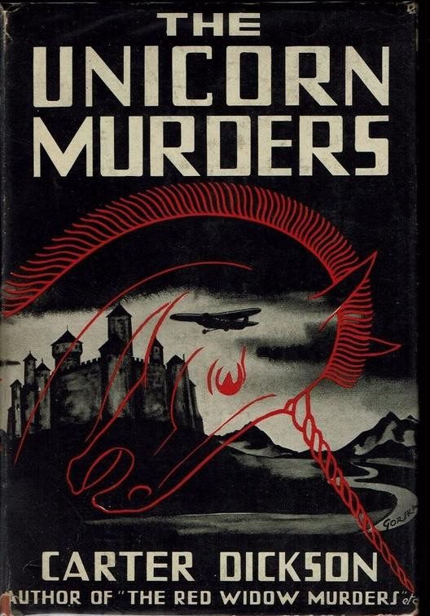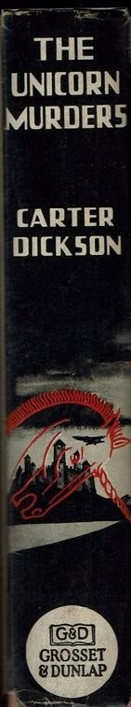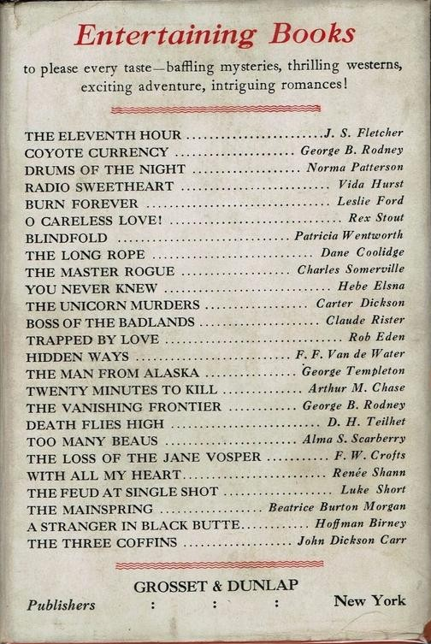

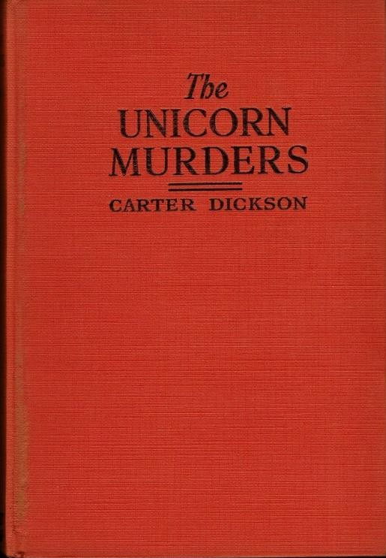

Dickson, Carter

The unicorn murders
Grosset and Dunlap, New York 1935

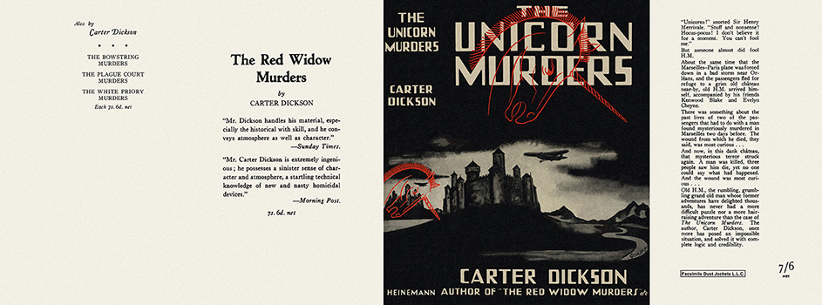

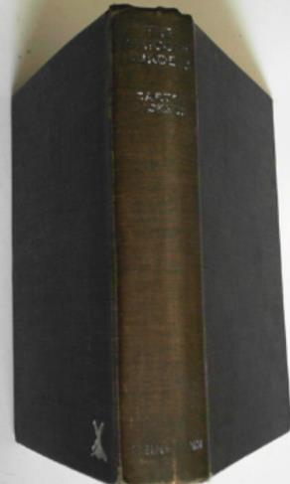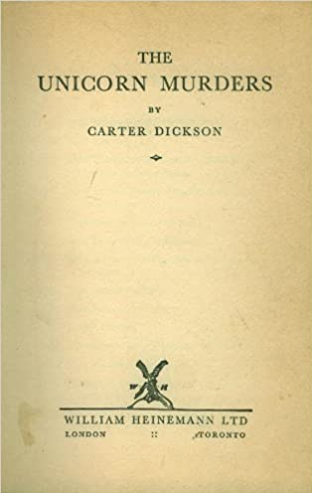

Dickson, Carter

The unicorn murders
Heinemann (UK) (1936) first printing

Суперобложки и внешний вид первых изданий книги

