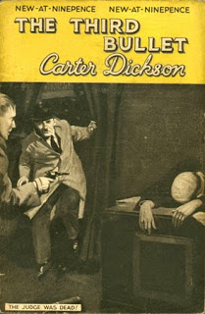

John Dickson Carr
The third bullet
Hodder & Stoughton (UK) 1937 first edition

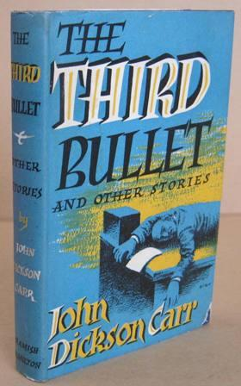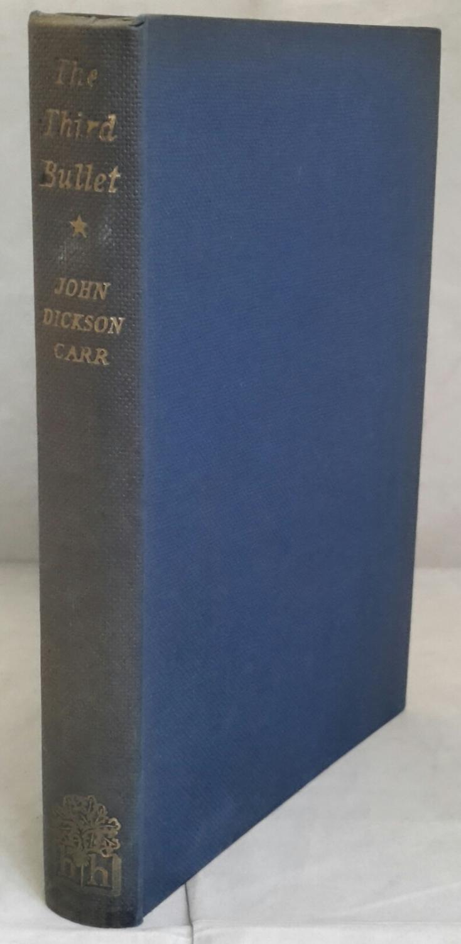

John Dickson Carr
The third bullet and other stories
Hamish Hamilton (UK) 1954

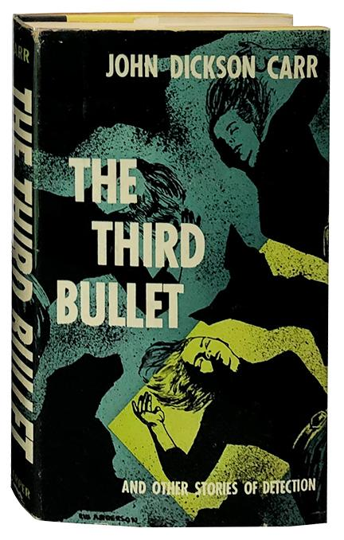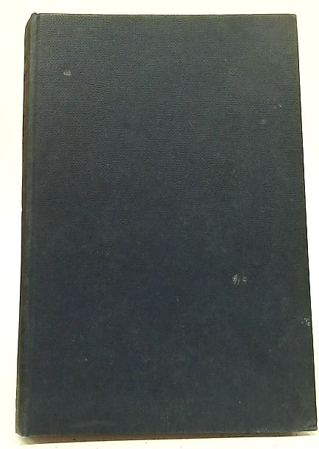

John Dickson Carr

The third bullet and other stories of detection
Harper and Brothers (USA) 1954

Внешний вид ранних изданий повести

