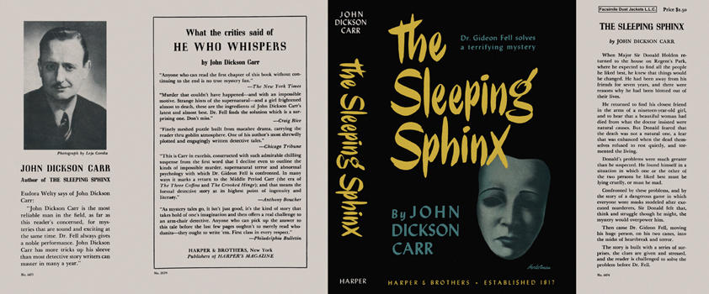

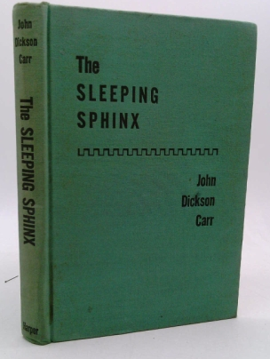

Carr, John Dickson

The sleeping sphinx
Harper & Brothers (USA) (1947) first printing.

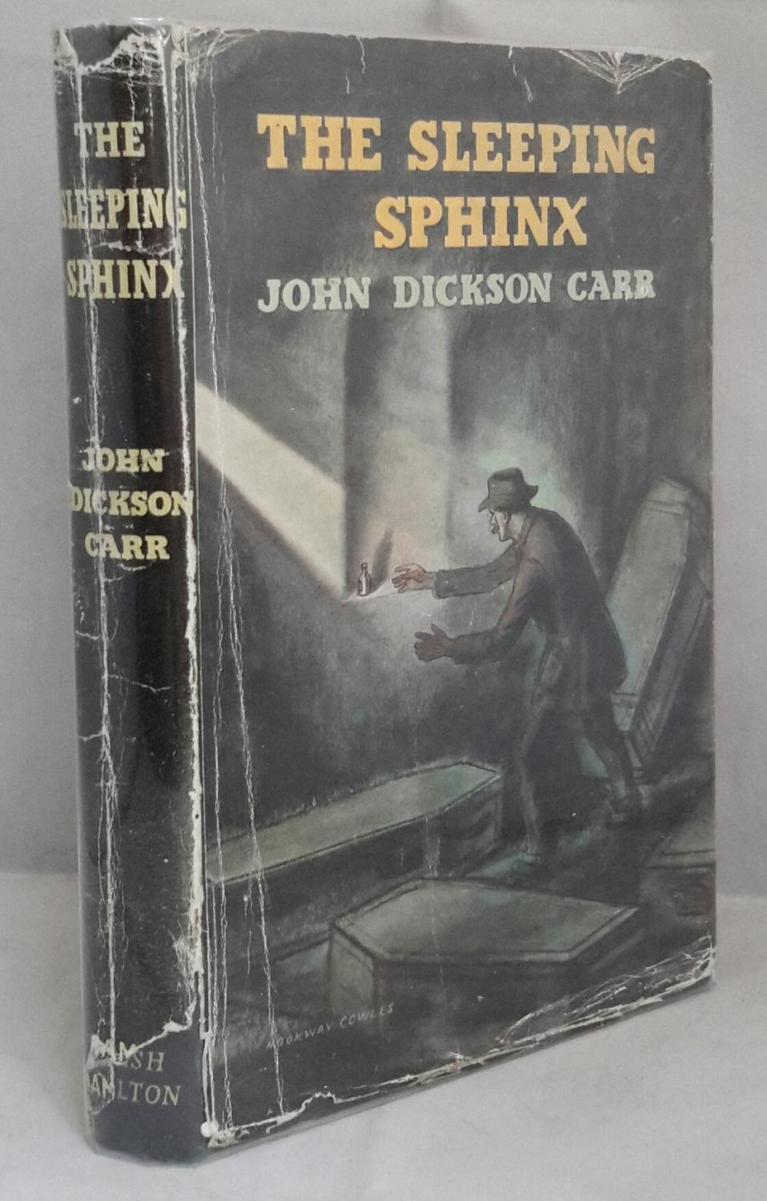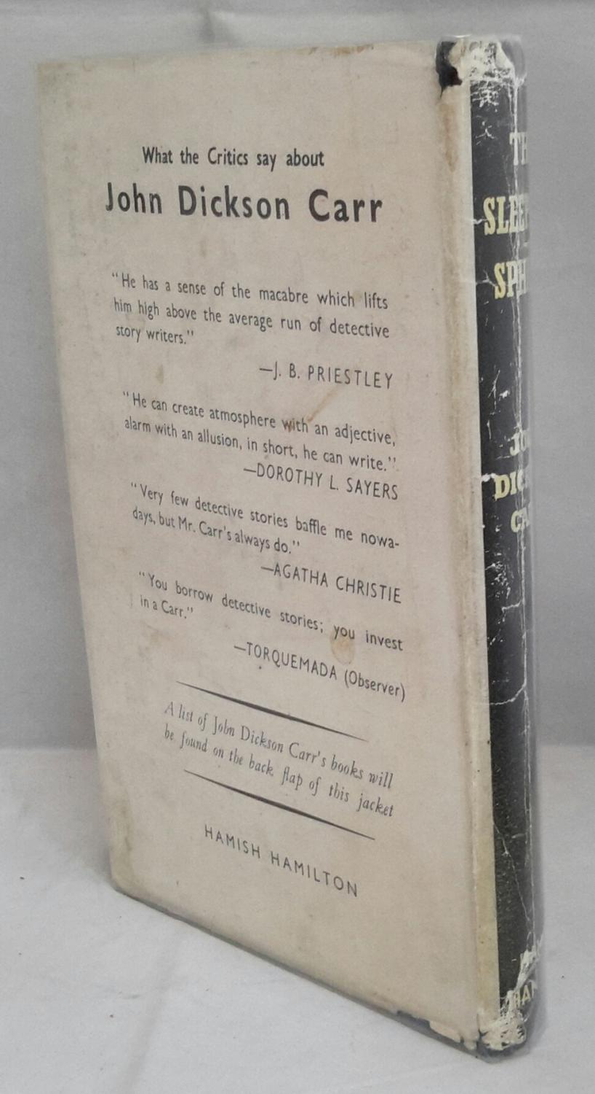



Carr, John Dickson

The sleeping sphinx
Hamish Hamilton (UK) (1947) first edition

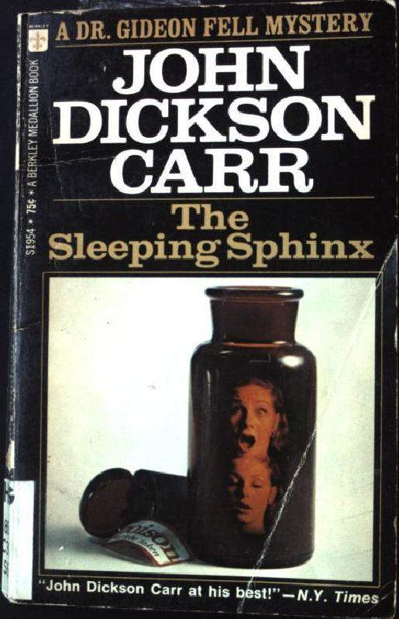

Carr, John Dickson

The sleeping sphinx
Berkley Medallion Book ((USA) (1947)

Суперобложки и внешний вид первых изданий книги

