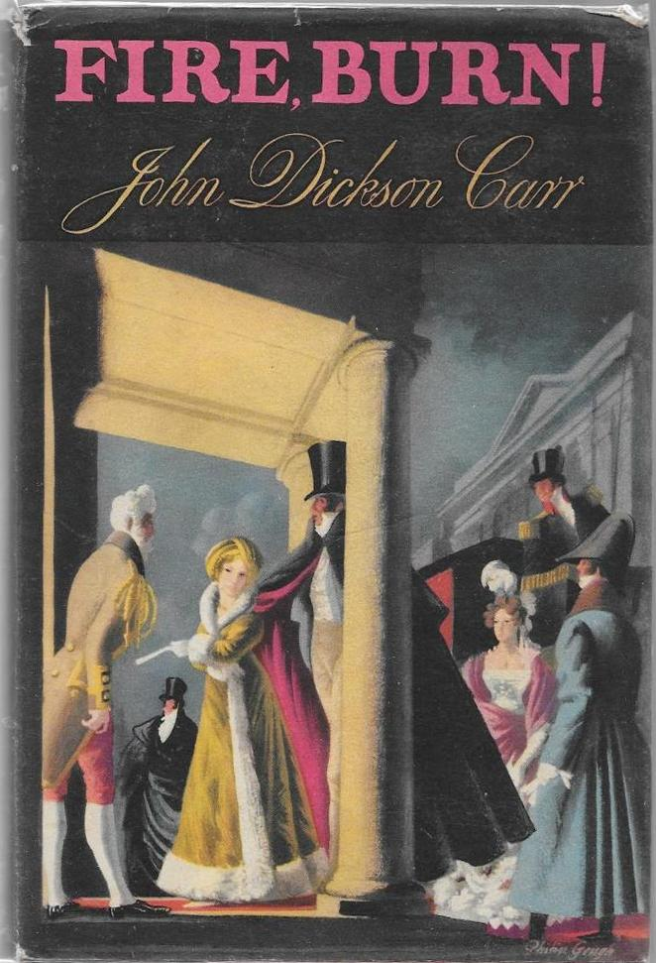

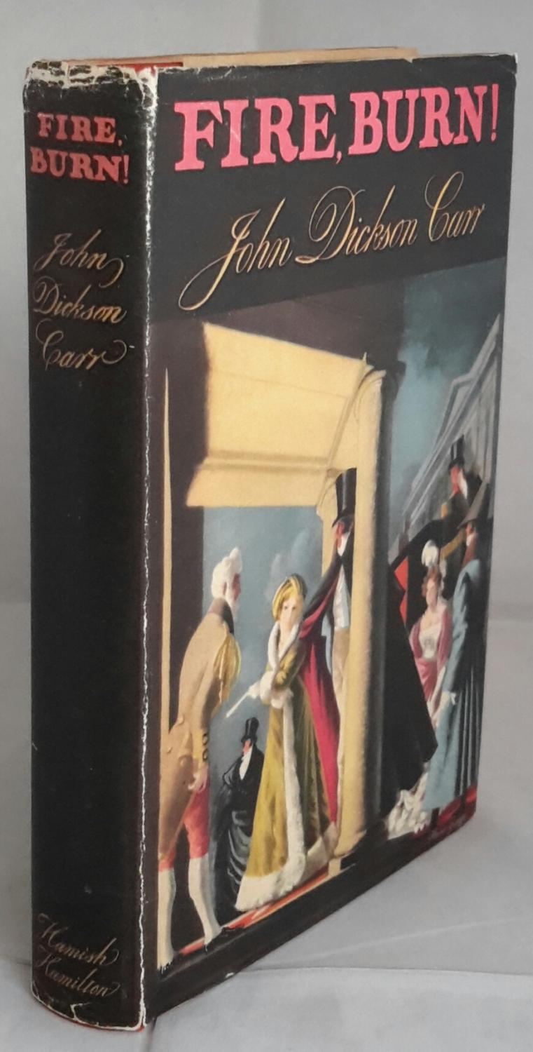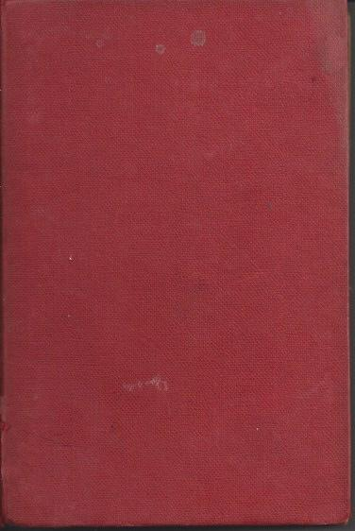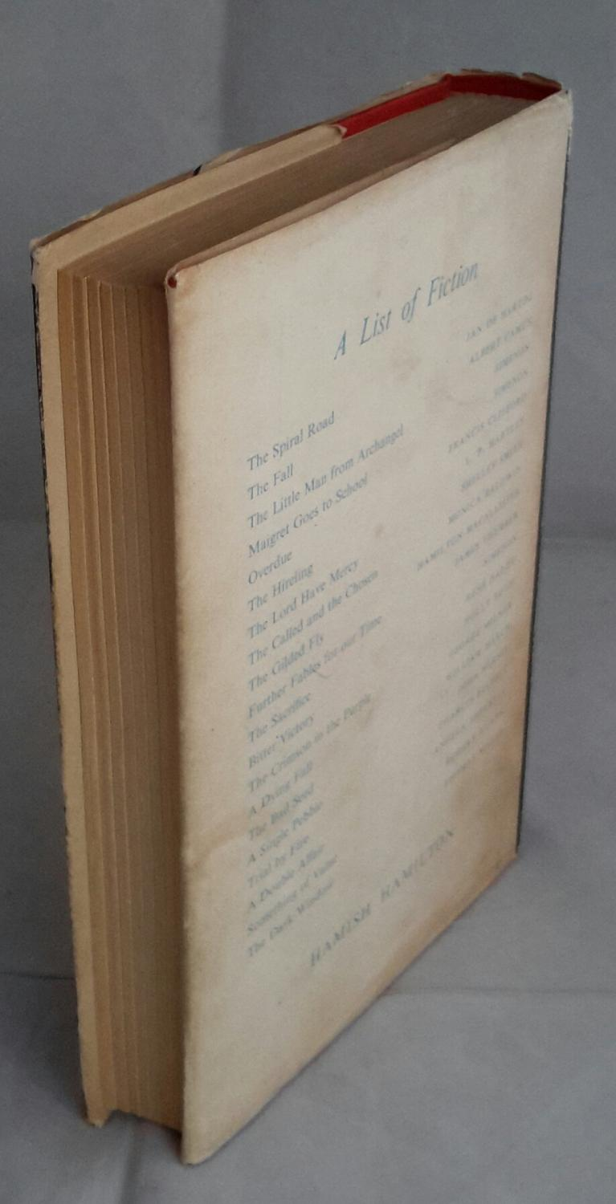

Carr, John Dickson

Fire, burn!
Hamish Hamilton Ltd, London (1957) first printing

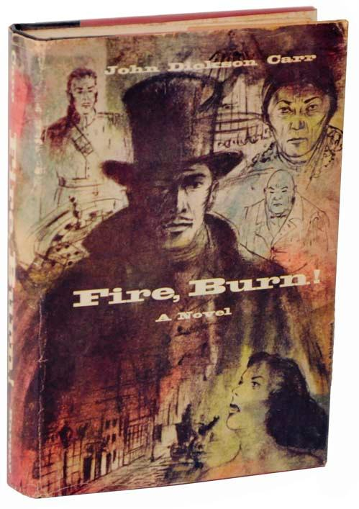

Carr, John Dickson

Fire, burn!
Harper & Row, New York, 1957 first printing

Суперобложки и внешний вид первых изданий книги

