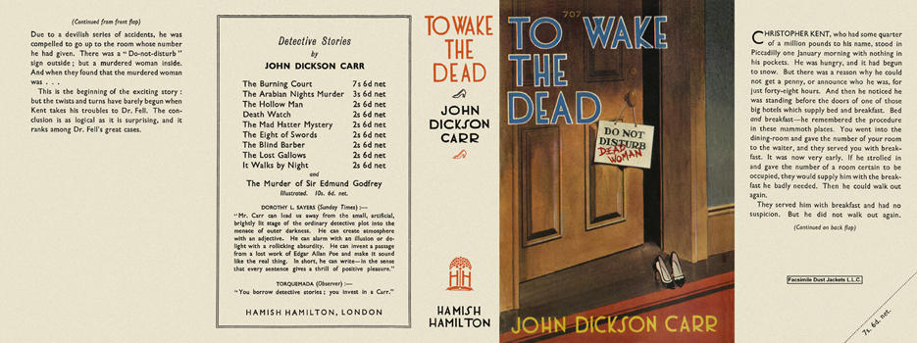

Carr, John Dickson
To wake the dead
Hamish Hamilton (UK) (1937) first printing

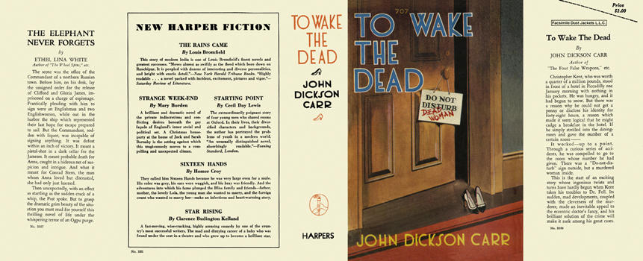

Carr, John Dickson
To wake the dead
Harper & Brothers (USA) (1938) first printing

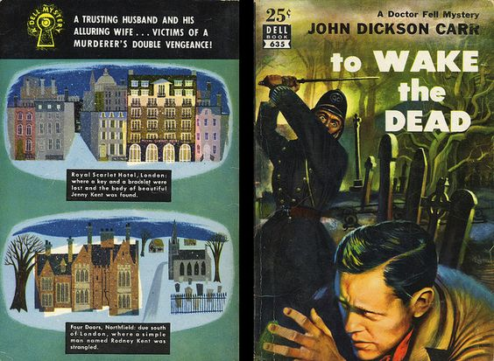

Carr, John Dickson
To wake the dead
Dell Publishing (USA) (1938), Paperback N 635

Обложки первых изданий книги

