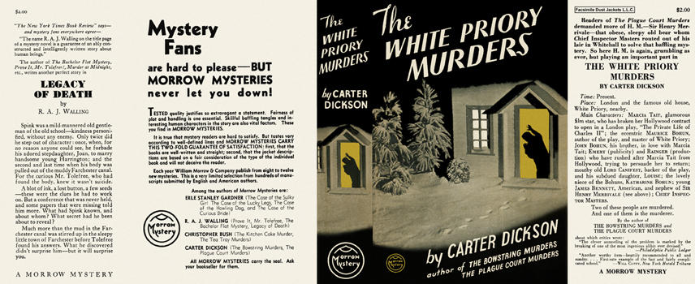

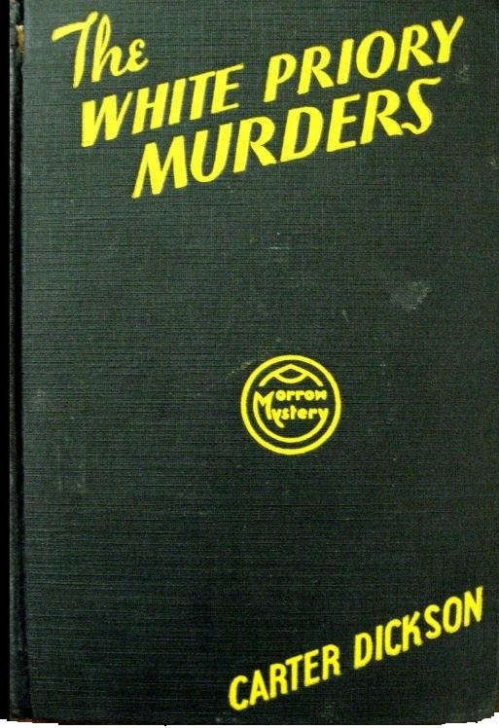

Dickson, Carter
The White Priory murders
Morrow Mystery (USA) (1934) first printing

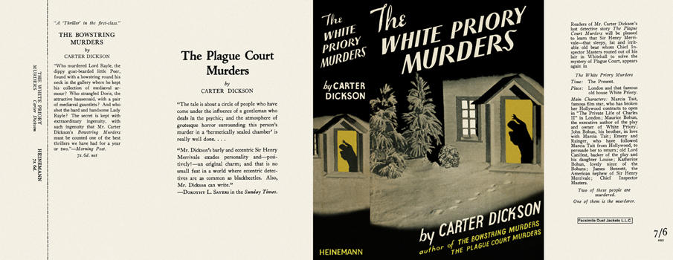

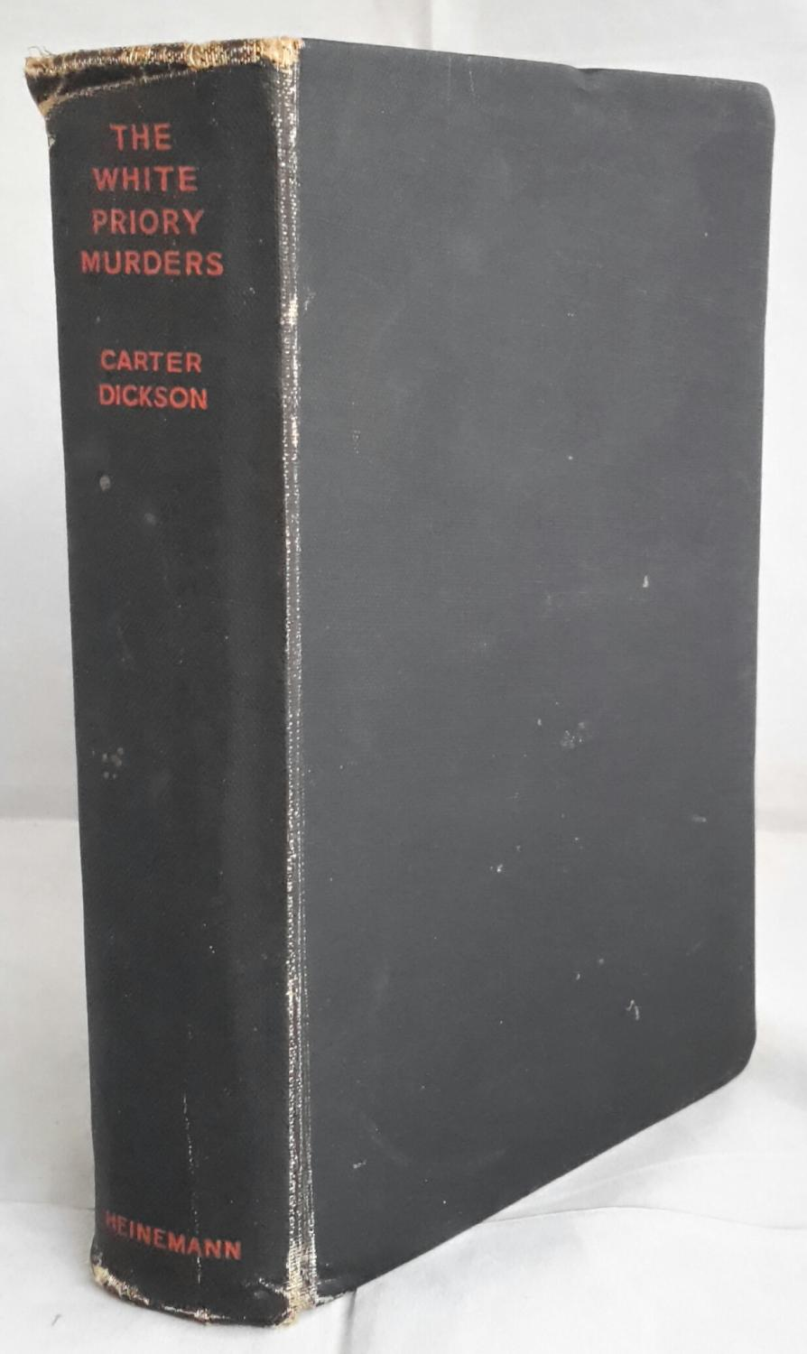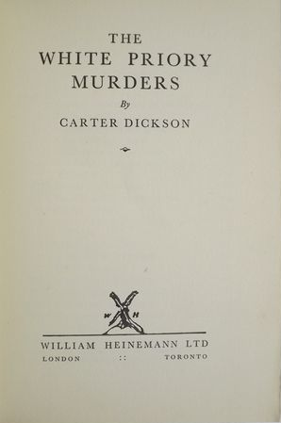

Dickson, Carter
The White Priory murders
Heinemann (UK) (1935) first printing.

Суперобложки и внешний вид первых изданий книги

