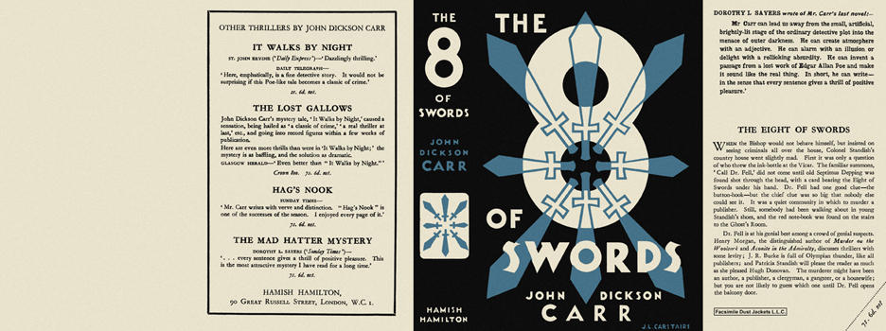

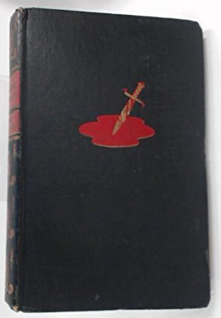

Carr, John Dickson

The eight of swords
Hamish Hamilton (UK) (1934) first printing

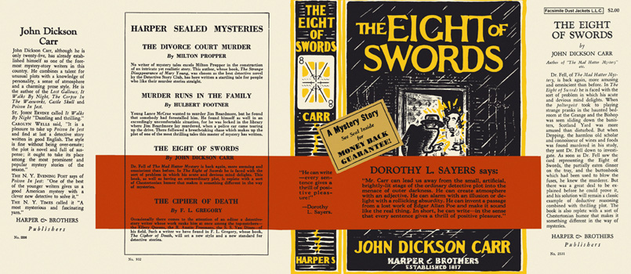

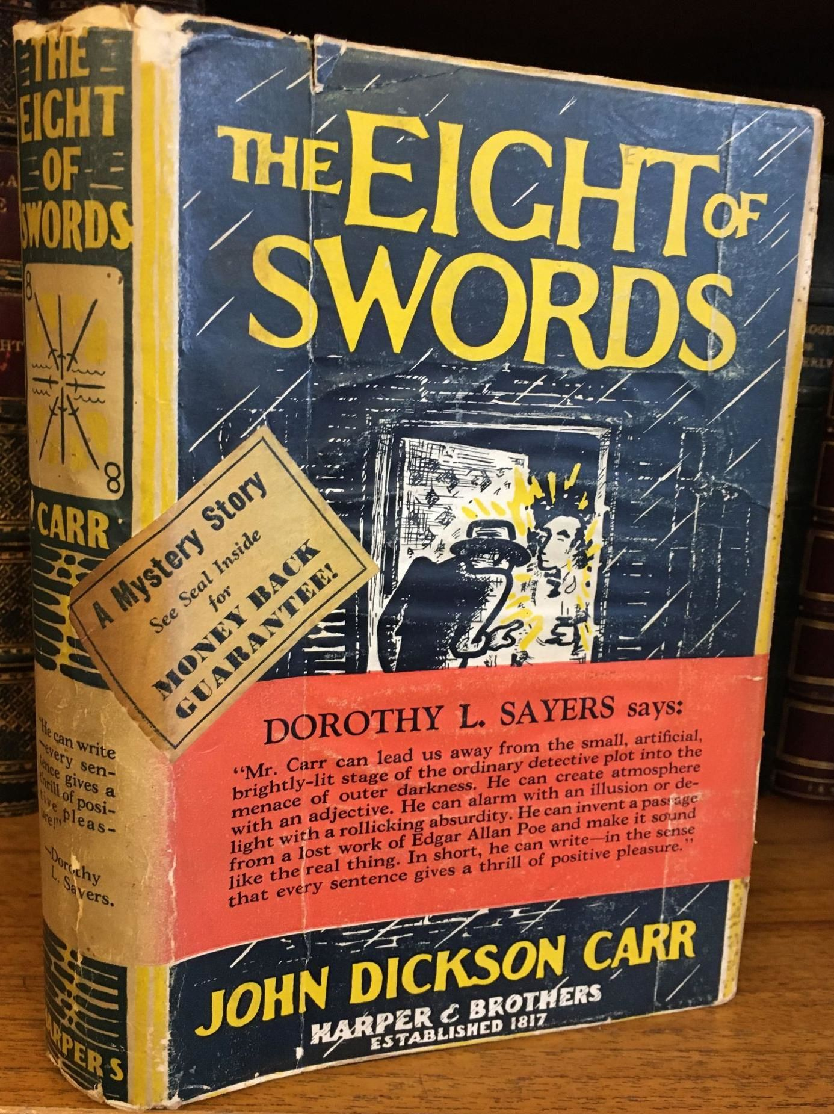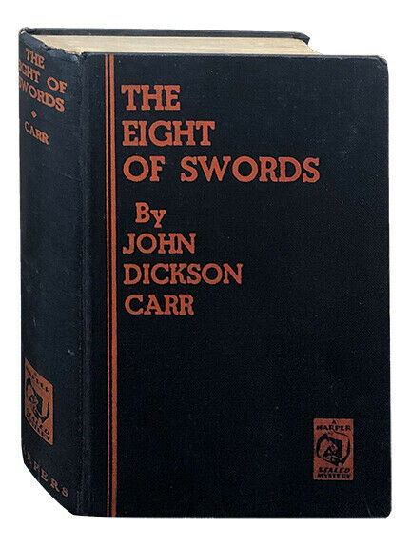

Carr, John Dickson

The eight of swords
Harper & Brothers (USA) (1934) first printing with seal sticker.

Суперобложки и внешний вид первых изданий книги

