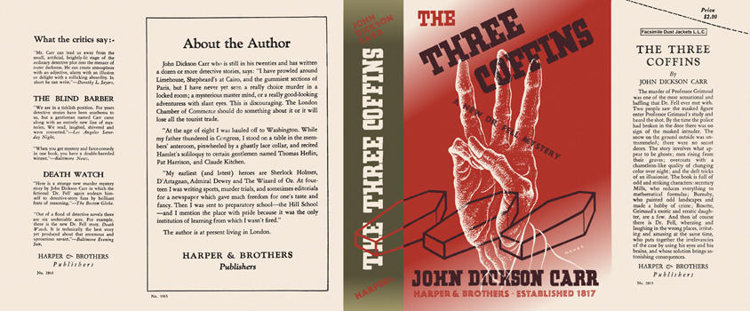

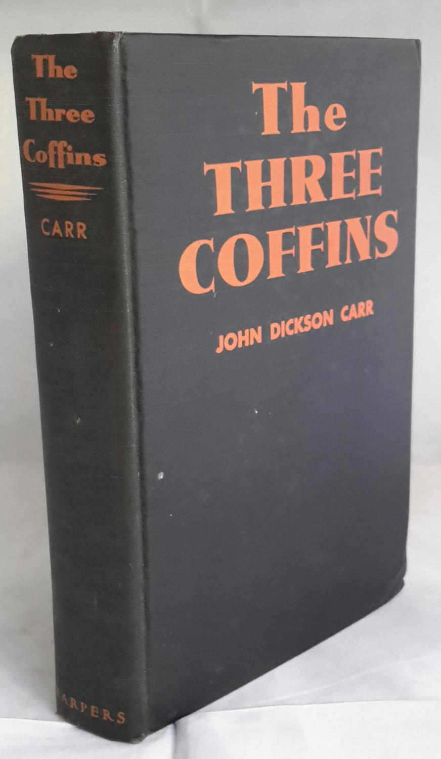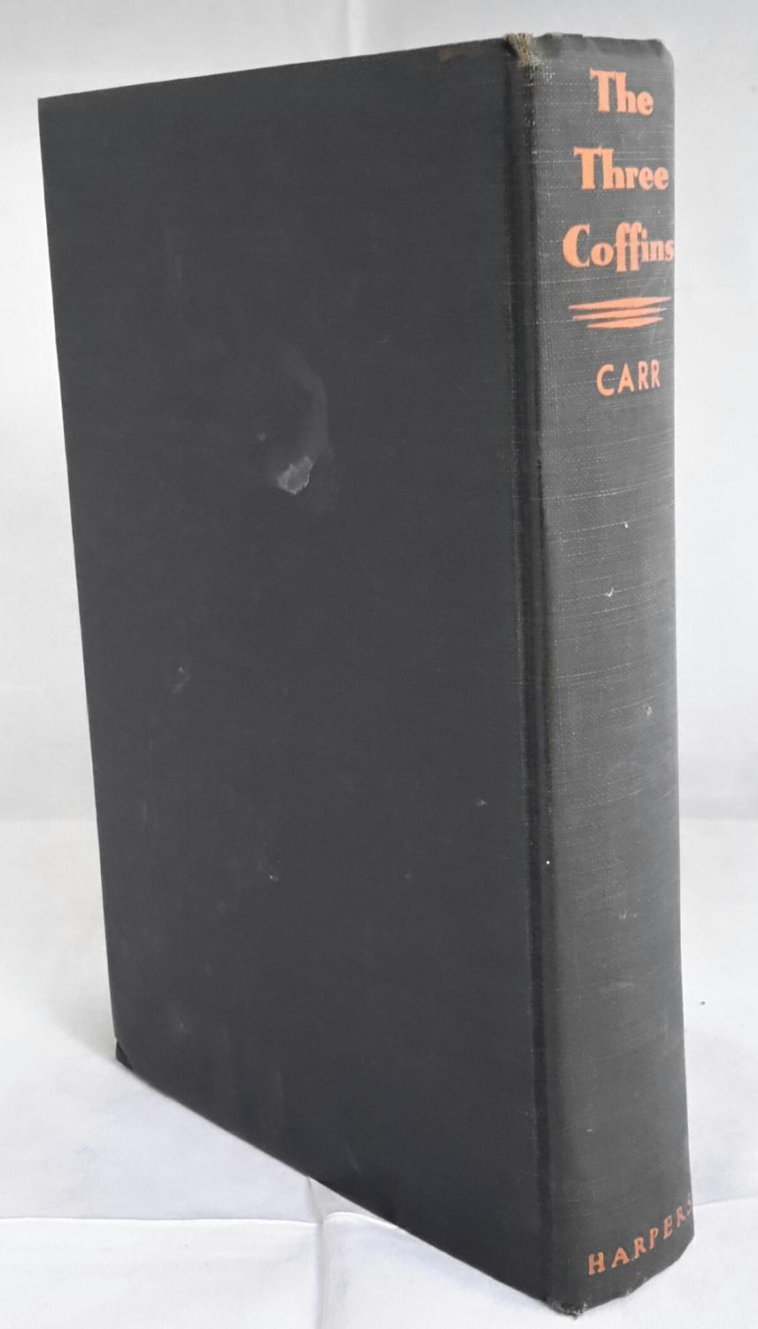

Carr, John Dickson
The three coffins
Harper & Brothers (USA) (1935) first printing.

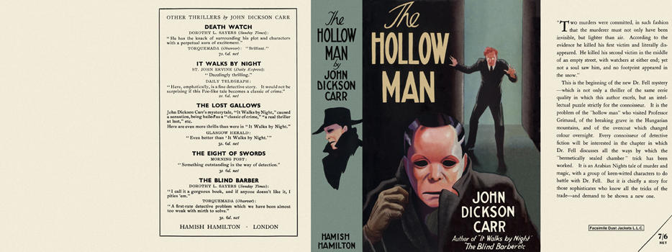

Carr, John Dickson
The hollow man
Hamish Hamilton (UK) (1935) first printing

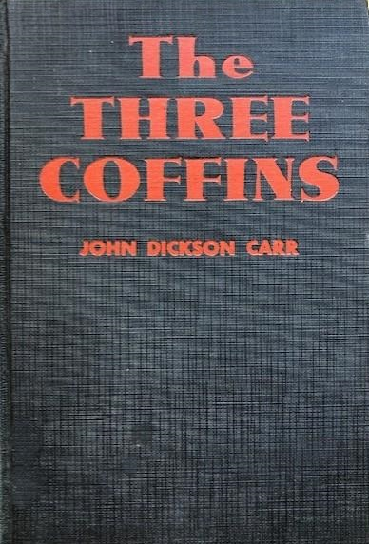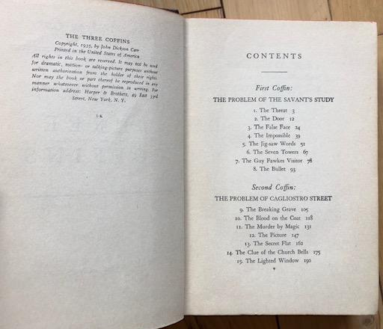

Carr, John Dickson
The three coffins
Grosset & Dunlap (US) (1935) first edition

Суперобложки и внешний вид первых изданий книги

