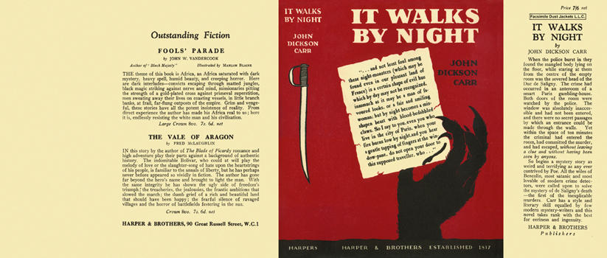

Carr, John Dickson
It walks by night
Harper & Brothers (UK) (1930) first printing.

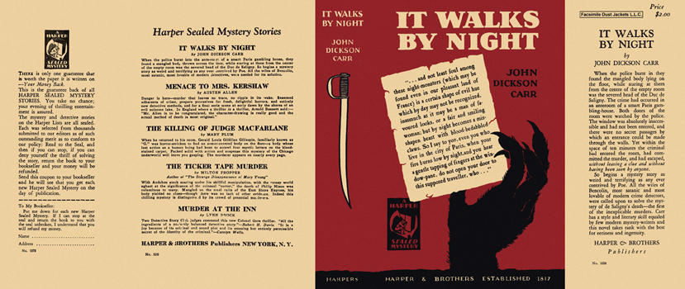

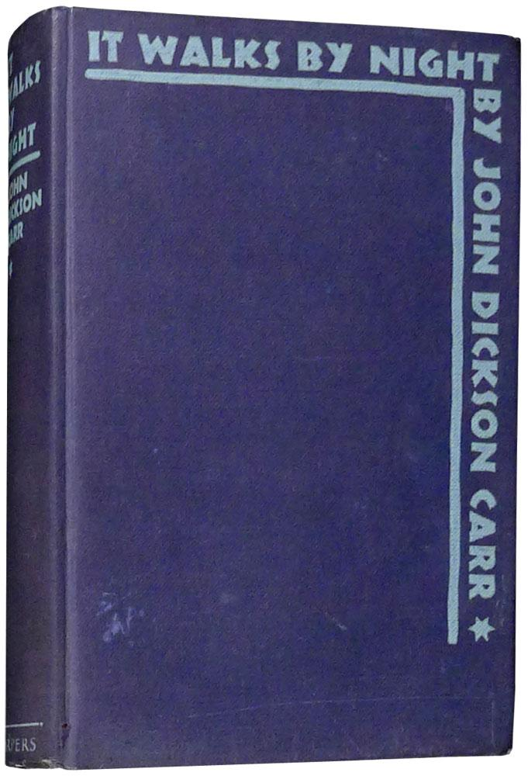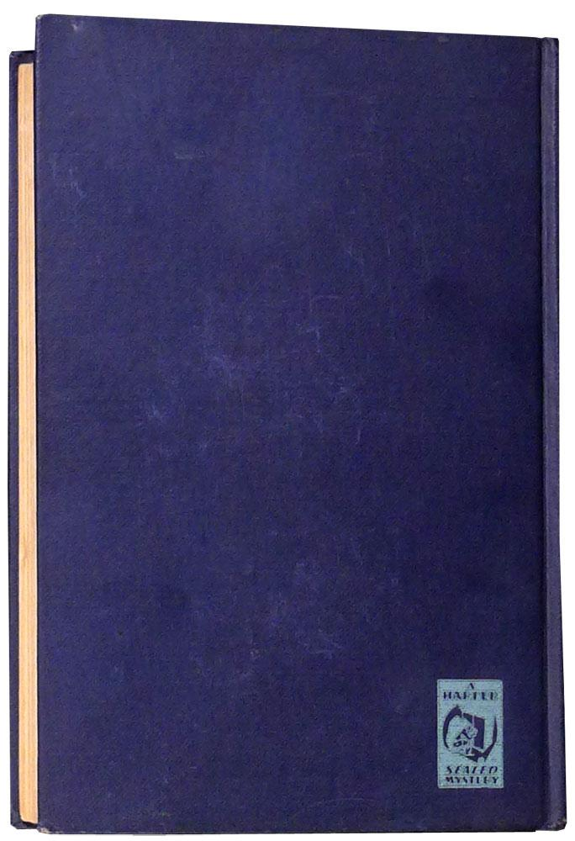

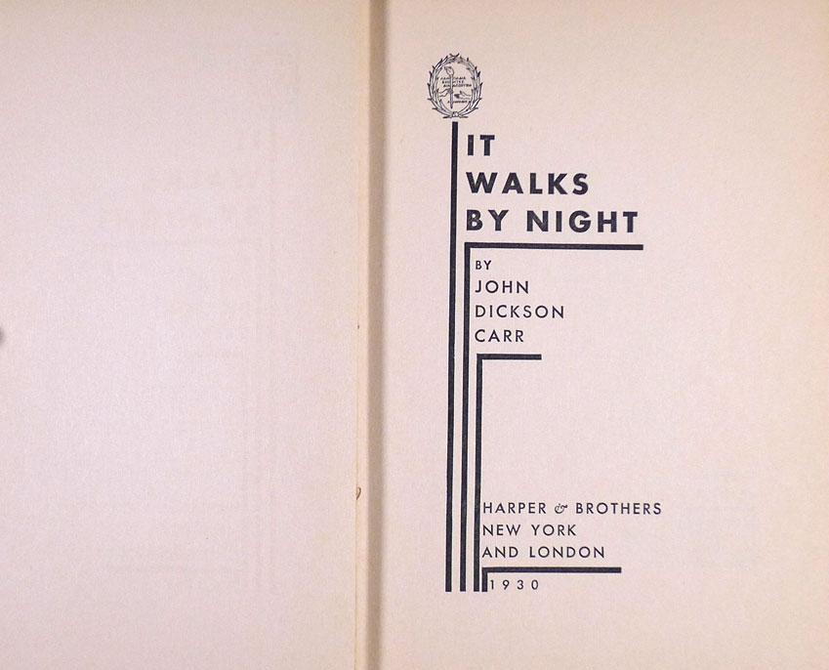

Carr, John Dickson
It walks by night
Harper & Brothers (USA) (1930) first printing.

Суперобложки и внешний вид первых изданий книги

