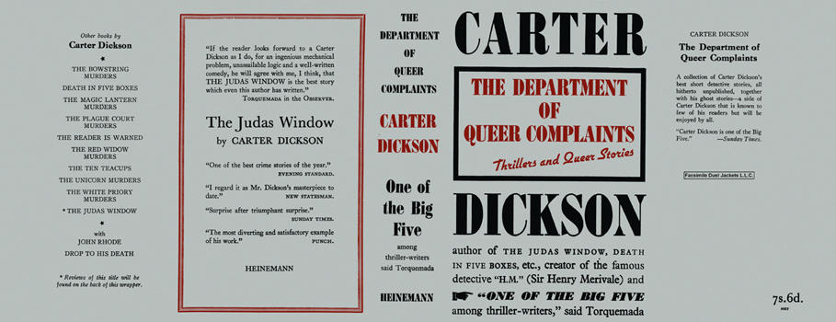

Dickson, Carter
The department of queer complaints
Heinemann (UK) (1940) first printing.

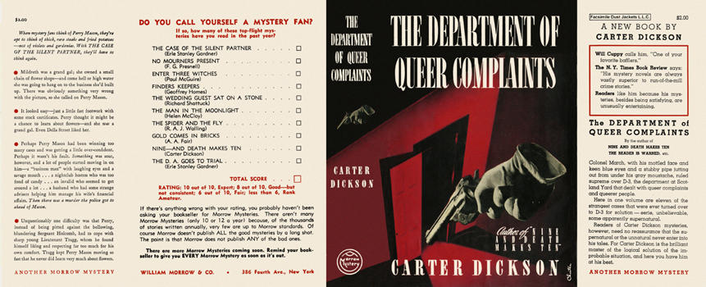

Dickson, Carter
The department of queer complaints
Morrow Mystery (USA) (1940) first printing

Суперобложки первых изданий сборника, в который вошли рассказы
The silver curtain и The footprint in the sky

