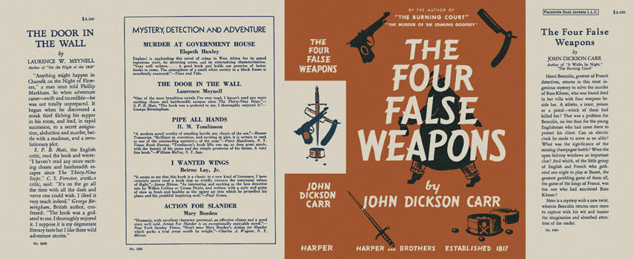

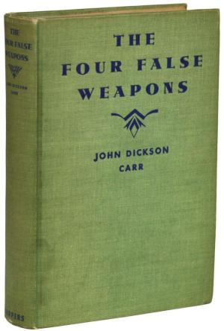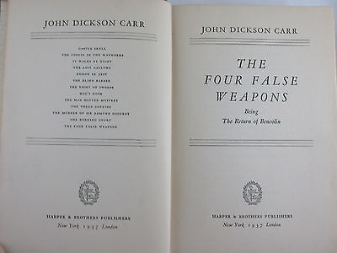

Carr, John Dickson
The four false weapons
Harper & Brothers (USA), 1937
first printing

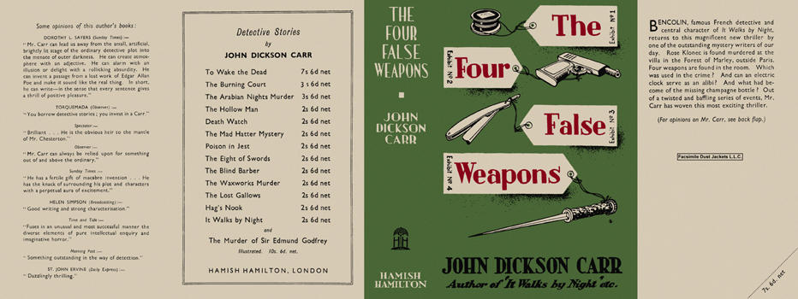

Carr, John Dickson
The four false weapons
Hamish Hamilton (UK), 1938
first printing

Внешний вид первых изданий книги

