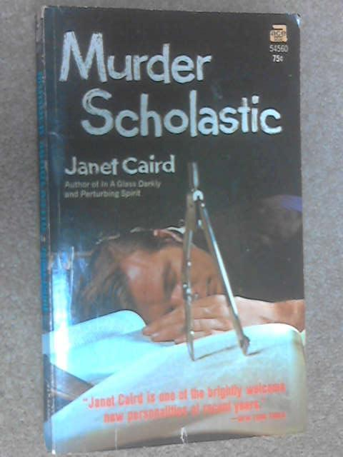

Caird J. Murder scholastic. New York: Ace books Inc., 1967

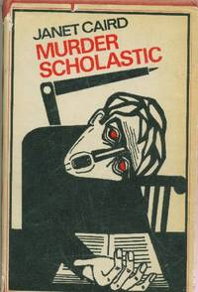

Caird J. Murder scholastic. London: Geoffrey Bles, 1967

