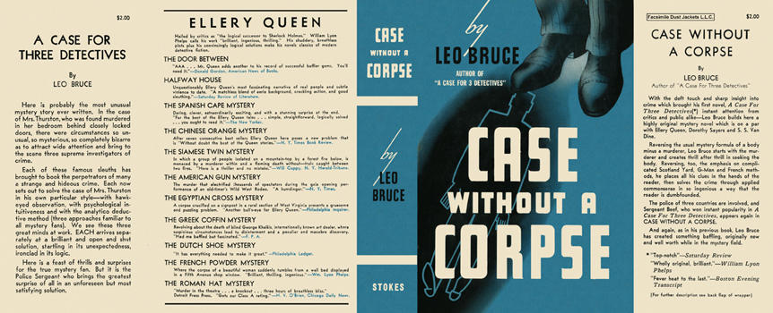

Bruce, Leo
Case without a corpse
Frederick A. Stokes Company (USA), 1937
first printing

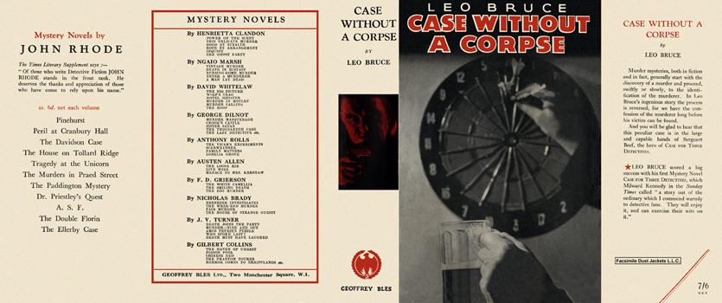

Bruce, Leo
Case without a corpse
Geoffrey Bles Ltd. (UK), 1937
first printing

Суперобложки первых изданий книги

