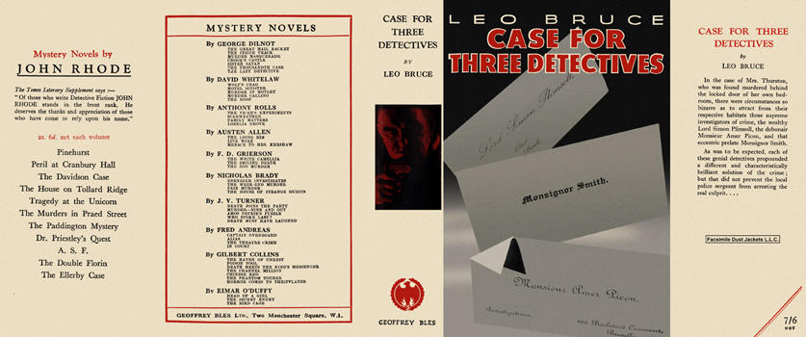

Bruce, Leo
A case for three detectives
Geoffrey Bles Ltd. (UK) (1936) first printing.

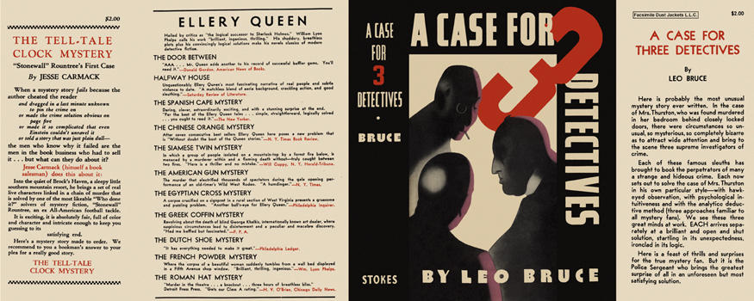

Bruce, Leo
A case for three detectives
Frederick A. Stokes Company (USA) (1937) first printing

Суперобложки первых изданий романа

