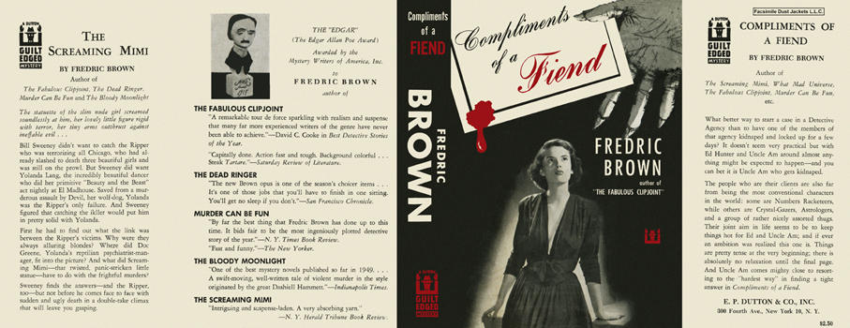

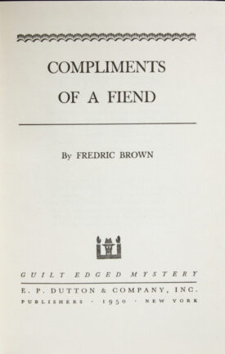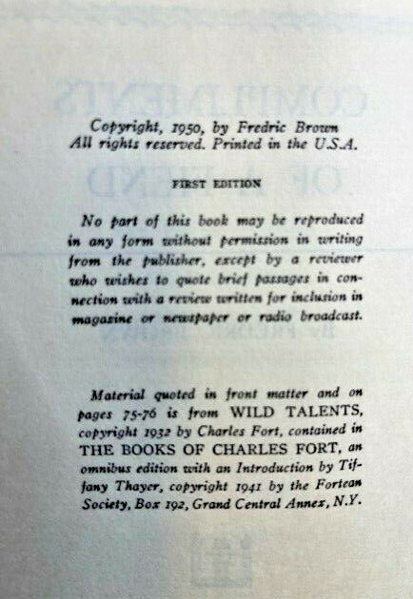

Brown, Fredric
Compliments of a fiend
E. P. Dutton & Co., Inc. (USA) (1950) first printing

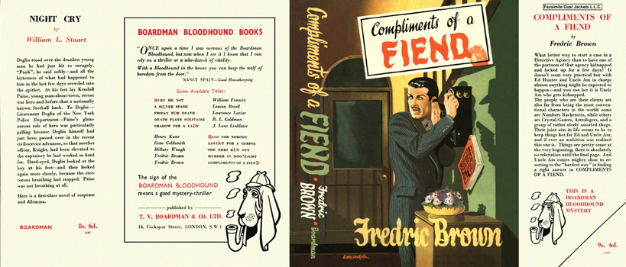

Brown, Fredric
Compliments of a fiend
T. V. Boardman and Company Limited (UK) (1951) first printing

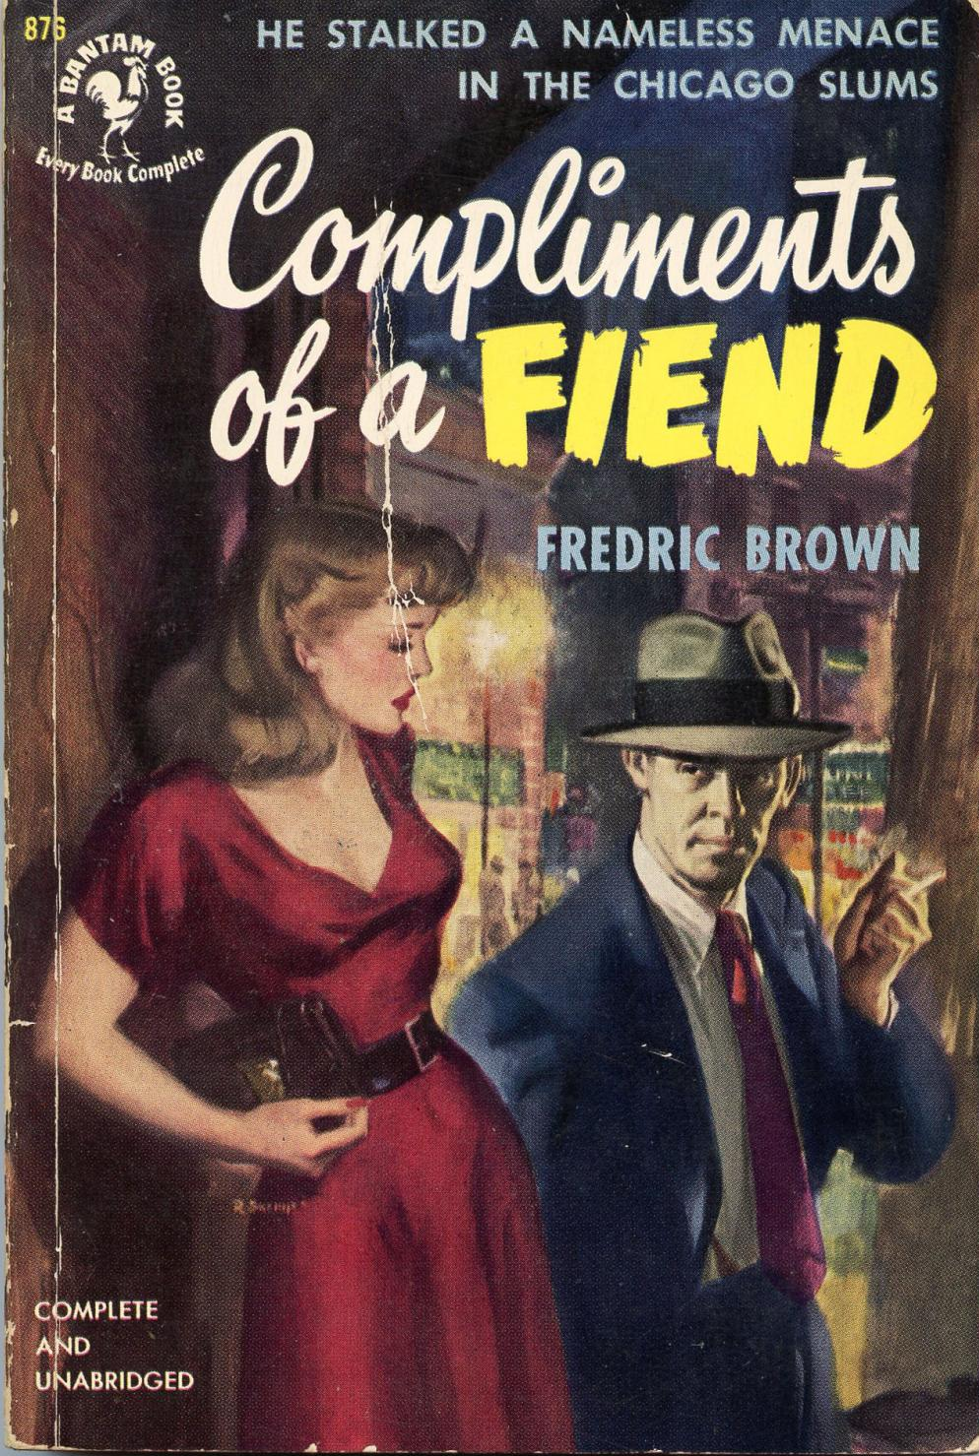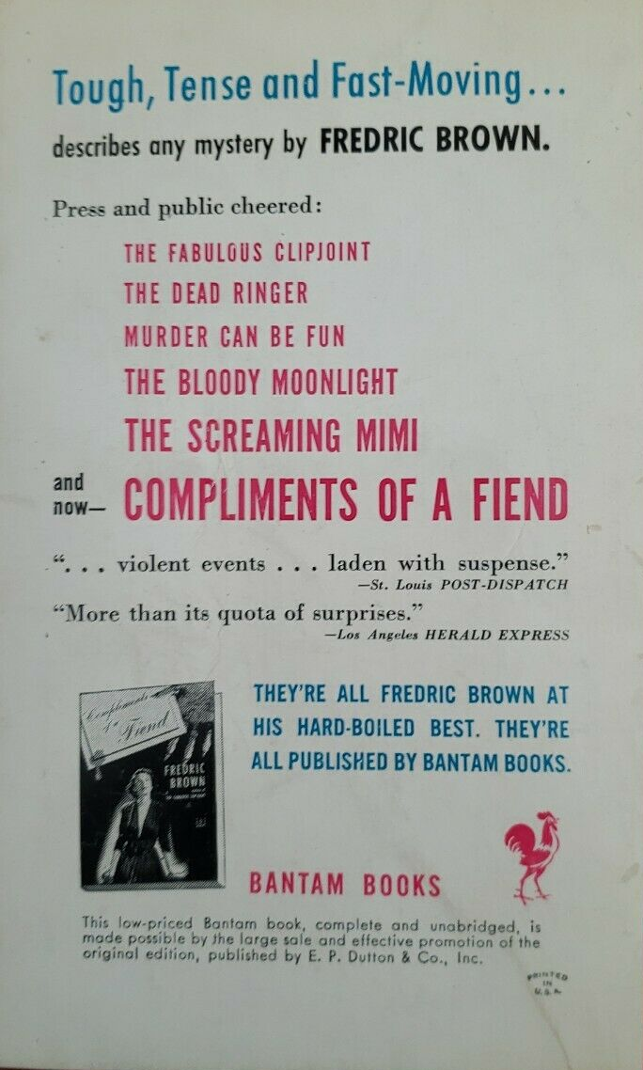

Brown, Fredric
Compliments of a fiend
Bantam Books (USA) (1951) first printing

Обложки и внешний вид первых изданий романа

