

Brand, Christianna

Suddenly at His Residence
John Lane, The Bodley Head (UK) (1947) first printing.

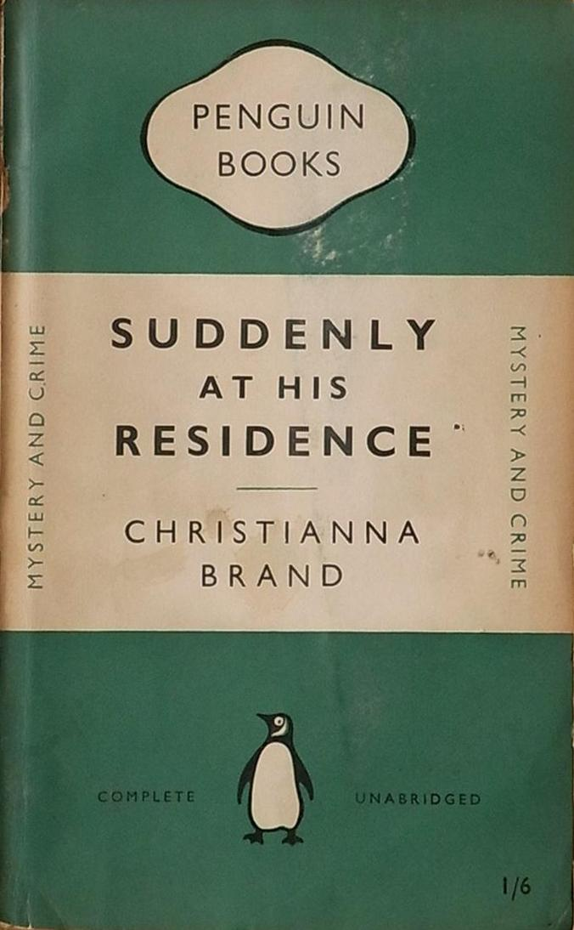

Brand, Christianna

Suddenly at His Residence
Penguin Books (UK), 1951

Обложки ранних изданий романа

