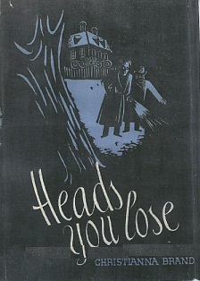

Brand, Christianna
Heads you lose
John Lane, The Bodley Head (UK) (1941) first printing



Brand, Christianna
Heads you lose
Dodd, Mead & Co (USA), 1942, first printing

Обложки первых изданий романа

