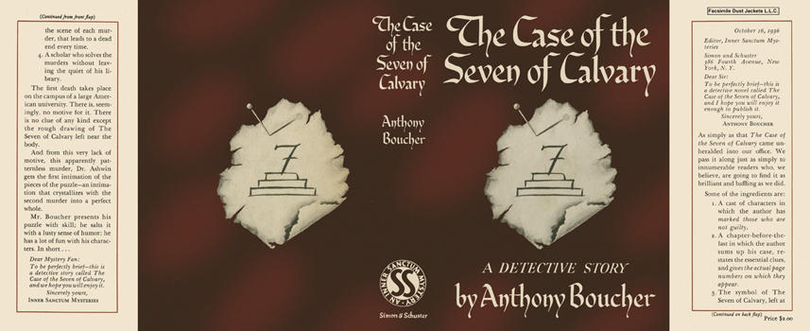

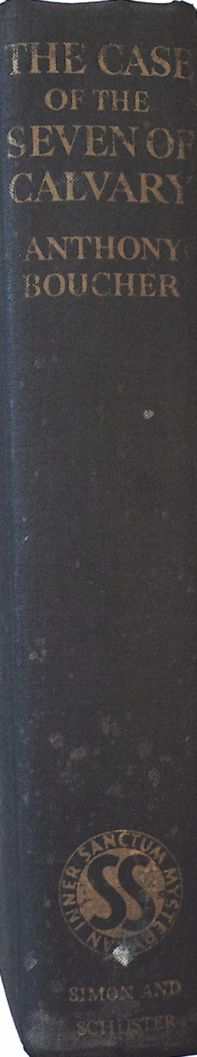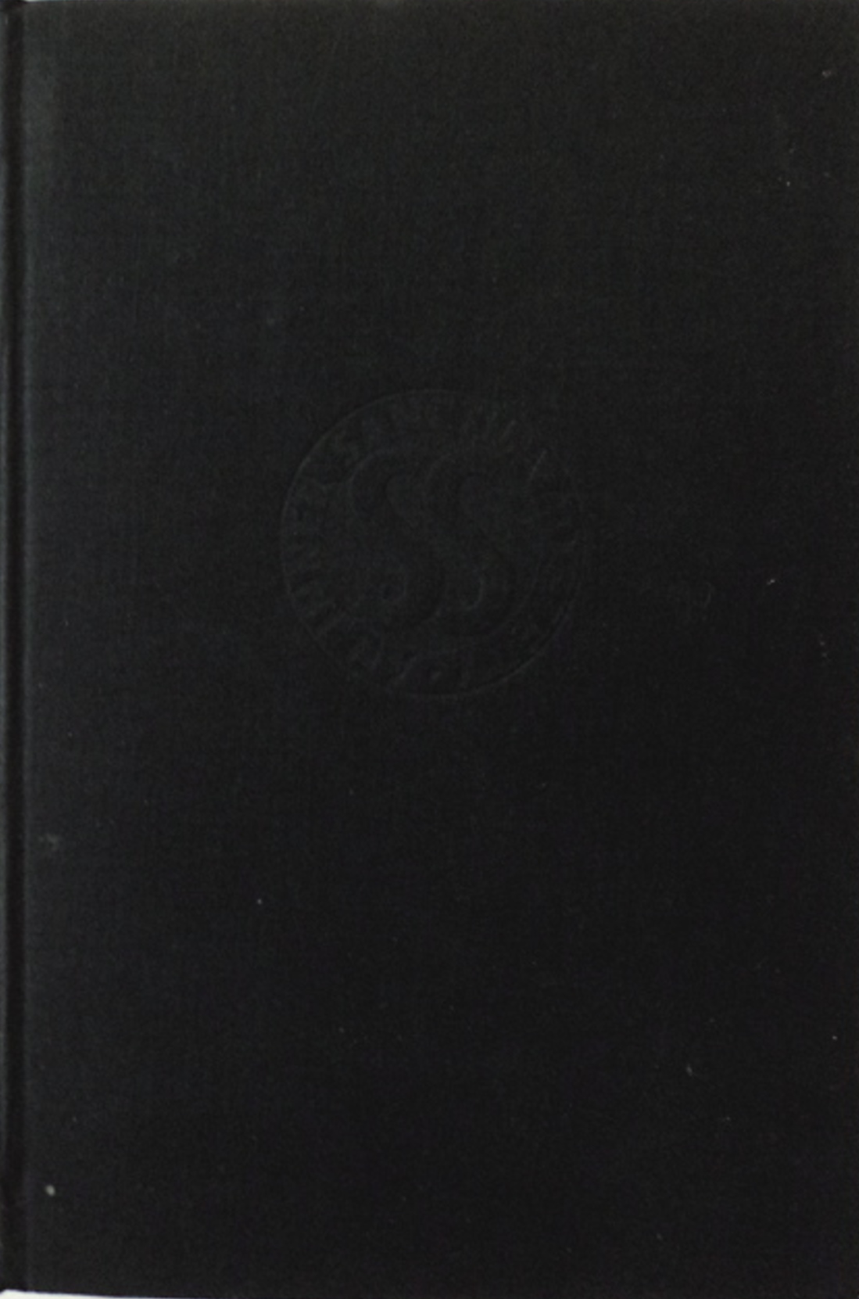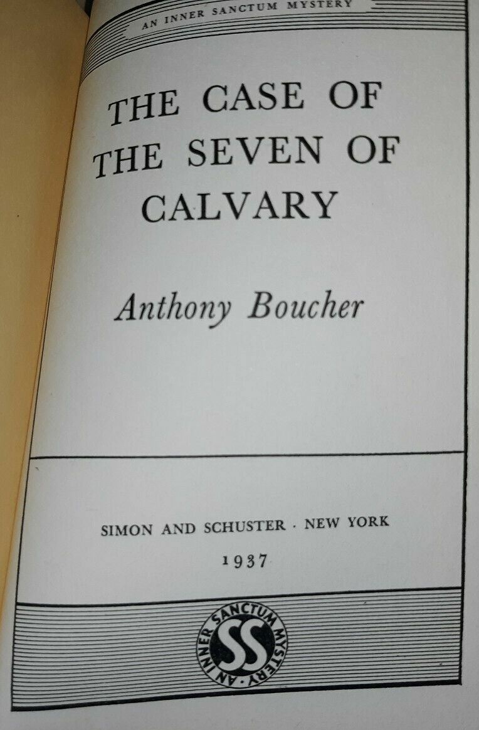

Boucher, Anthony
The case of the seven of Calvary
Simon and Schuster (USA) (1937) first printing

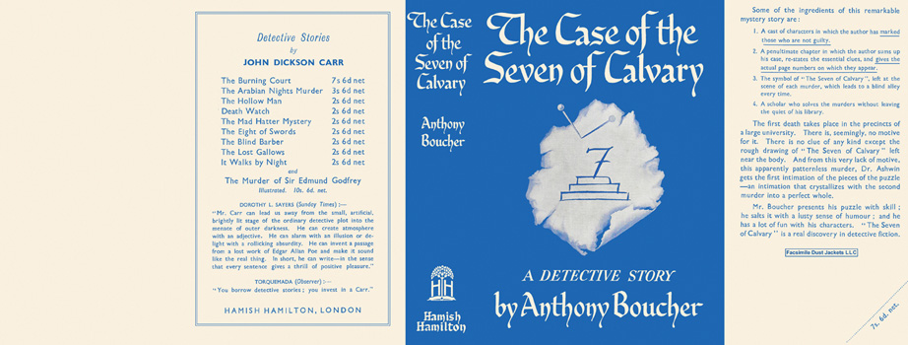

Boucher, Anthony
The case of the seven of Calvary
Hamish Hamilton (UK) (1937) first printing

Суперобложки и внешний вид первых изданий книги

