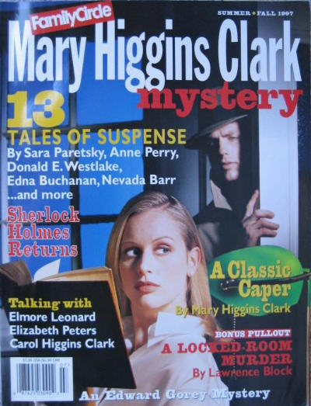

Mary Higgins Clark Mystery Magazine [v23 #3, Summer/Fall 1997]
Pages 57-72 are a digest size pull-out of “The Burglar Who Smelled Smoke”.

  - 1 · In Defense of Suspense · Mary Higgins Clark · ed
  - 5 · Four Authors in Search of a Character
  - _5 · The Inspector as Iconoclast · Rosemary Herbert · bg [Ref. Colin Dexter].
  - _6 · The Indomitable Amelia · Rosemary Herbert · bg [Ref. Elizabeth Peters].
  - _7 · Regular Guys—and Gals—with a Twist · Tom Nolan · bg [Ref. Elmore Leonard].
  - _8 · The Female PI Next Door · Yona Zeldis McDonough · bg [Ref. Carol Higgins Clark].
  - 9 · Foolproof · Edna Buchanan · ss
  - 15 · Heartbreak House · Sara Paretsky · ss Murder for Love ed. Otto Penzler, Delacorte, 1996
  - 22 · A Matter of Blackmail · Anne Perry · ss Murder for Love ed. Otto Penzler, Delacorte, 1996
  - 28 · The Deadly Blotter: An Alphabetical Mystery · Edward Gorey · cs
  - 30 · Fatal Flaw · Andrea Smith · ss
  - 40 · The Crimson Moccasins · Nevada Barr · ss
  - 45 · The White Death · Justin Scott · ss Beastly Tales ed. Sara Peretsky, Wynwood, 1989
  - 51 · Take It Away · Donald E. Westlake · ss
  - 57 · The Burglar Who Smelled Smoke [Bernie Rhodenbarr] · Lynne Wood & Lawrence Block ·
  - 73 · The Adventure of the Giant Rat of Sumatra by John H. Watson, M.D. · John T. Lescroart · ss
  - 82 · That’s the Ticket · Mary Higgins Clark · ss Mistletoe Mysteries ed. Charlotte MacLeod, The Mysterious Press, 1989
  - 89 · Quite Contrary · J. R. Chabot · ss
  - 93 · Merry Thieves · Robert Lee Hall · ss
  - 99 · Murder by the Book · Michele Slung · br
  - 100 · Booksellers’ Best Bets · Kate Stine · br
  - 102 · The Watching Detectives · Paula L. Woods · br
  - 103 · Mystery on the Air · Tom Nolan · ar
  - 108 · The Interrogation Room · Kate Stine · qz

Обложка журнала, в котором был впервые напечатан рассказ

