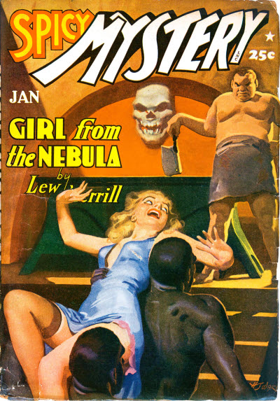

Spicy Mystery Stories [v11 #4, January 1942]

  - 6 · Girl from the Nebula · Lew Merrill · nv
  - 18 · An Artist at Murder · William B. Rainey · ss
  - 26 · Scrambled Justice · Paul Hanna · nv Spicy Mystery Stories September 1935, as “Master of Death” by Robert Leslie Bellem
  - 38 · Death, Advanced Stage · Walter Cook · ss Spicy Mystery Stories June 1936, as “Death’s Chrysalis” by Ellery Watson Calder
  - 50 · Vera Ray [Vera Ray] · Watt Dell · cs
  - 54 · Head of the Table · John Ford · ss Spicy Mystery Stories July 1936, as “Cross of Blood” by Ken Cooper
  - 66 · Lost Blood · Frank Decker · nv Spicy Mystery Stories July 1936, as “Tailor Made Dummy” by E. Hoffmann Price
  - 78 · No Sword, No Fire— · John Phillips · ss Spicy Mystery Stories July 1936, as “The Devil’s Mistress” by Charles A. Baker, Jr.

Обложка журнала, в котором впервые был напечатан рассказ

