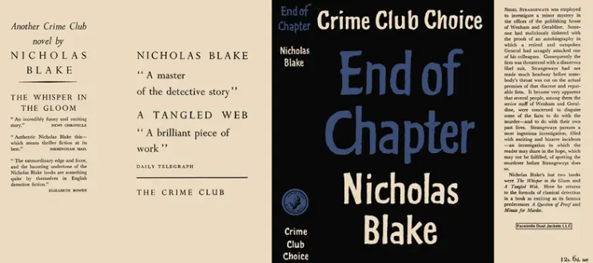

Blake, Nicholas
End of chapter
Collins The Crime Club (UK) (1957) first printing

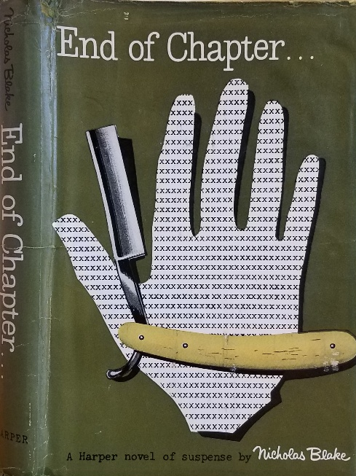

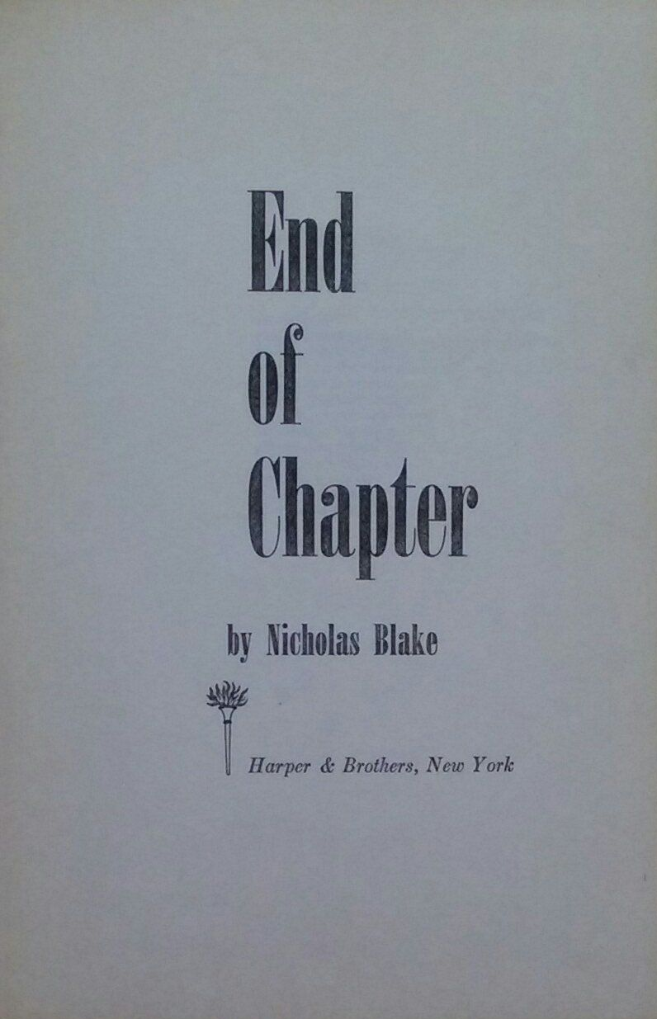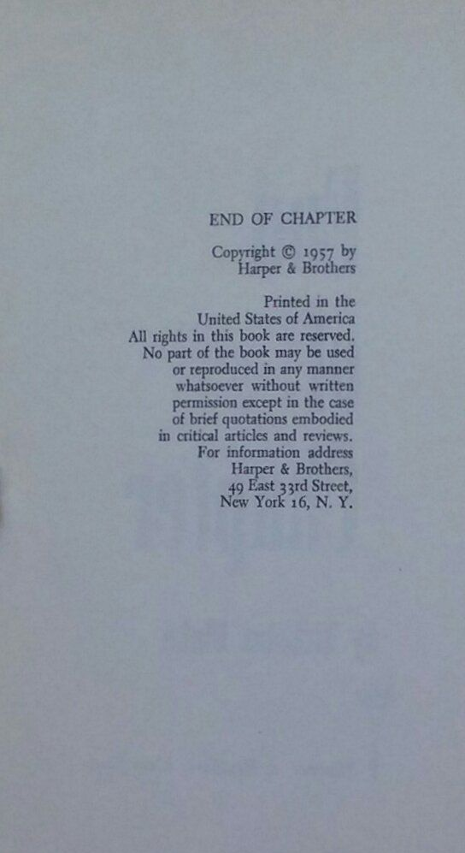

Blake, Nicholas
End of chapter
Harper and Brothers (USA) (1957) first printing

Суперобложка и внешний вид первых изданий романа

