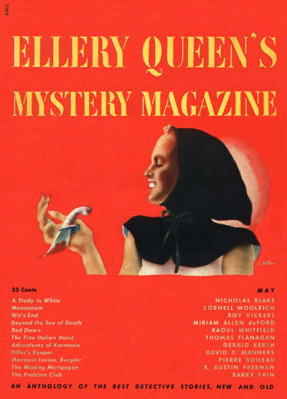

Ellery Queen’s Mystery Magazine, v13, N 66 (May 1949)
  - 3 · A Study in White · Nicholas Blake · ss The Strand Magazine Feb 1949, as “The Snow Line”
  - 15 · Momentum · Cornell Woolrich
  - 40 · Beyond the Sea of Death · Miriam Allen deFord
  - 58 · Monsieur Lucien—Burglar · Pierre Boileau; translated by Anthony Boucher
  - 65 · Red Dawn [Jo Gar] · Raoul Whitfield
  - 78 · Which Is the Heir? · Anon.
  - 81 · The Missing Mortgagee [Dr. John Thorndyke] · R. Austin Freeman
  - 97 · The Fine Italian Hand · Thomas Flanagan
  - 110 · The Adventures of Karmesin, 6: Karmesin, Con Man [Karmesin] · Gerald Kersh
  - 115 · The Problem Club [The Problem Club] · Barry Pain
  - 121 · Killer’s Keeper · David X. Manners
  - 128 · Wit’s End [Department of Dead Ends] · Roy Vickers

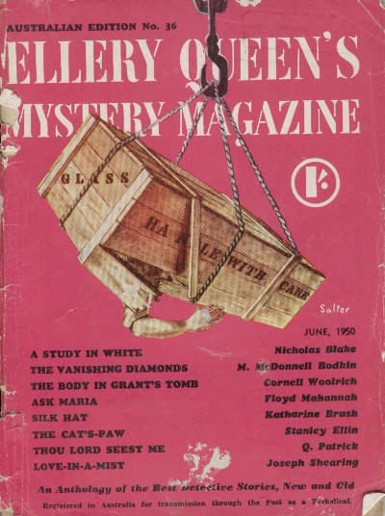

Ellery Queen’s Mystery Magazine (Australia), N 36 (June 1950)

  - 1 · A Study in White · Nicholas Blake · ss The Strand Magazine Feb 1949, as “The Snow Line”
  - 17 · The Vanishing Diamonds [Paul Beck] · M. McDonnell Bodkin
  - 36 · The Body in Grant’s Tomb · Cornell Woolrich
  - 63 · Ask Maria · Floyd Mahannah
  - 81 · Silk Hat · Katharine Brush
  - 85 · The Cat’s-Paw · Stanley Ellin
  - 99 · Thou Lord Seest Me · Q. Patrick
  - 118 · Love-in-a-Mist · Joseph Shearing

Обложки журналов, в которых был напечатан рассказ

