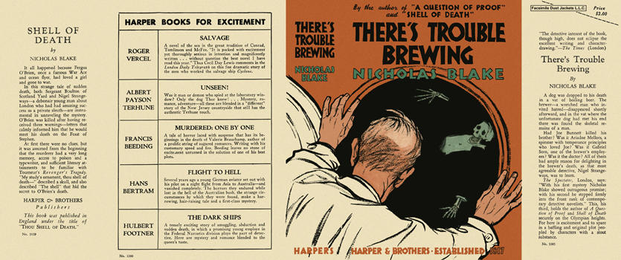

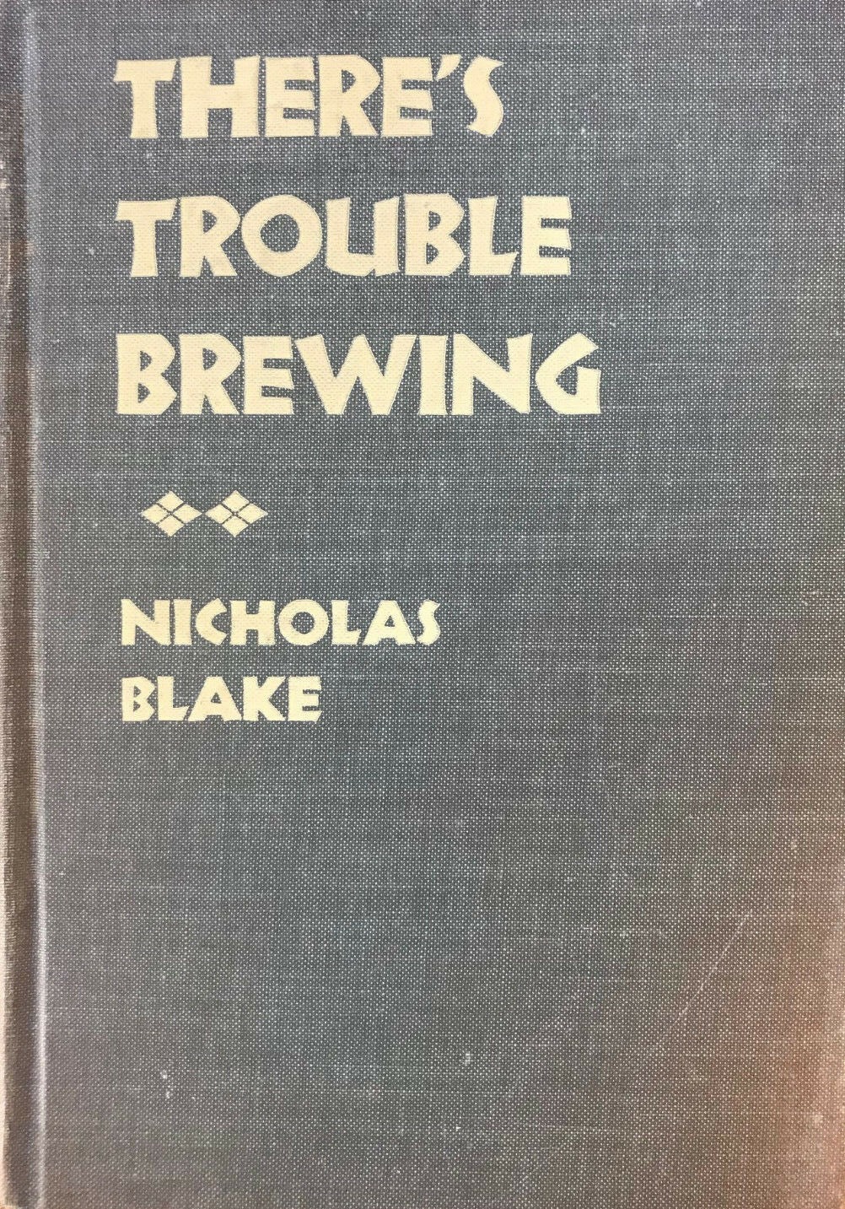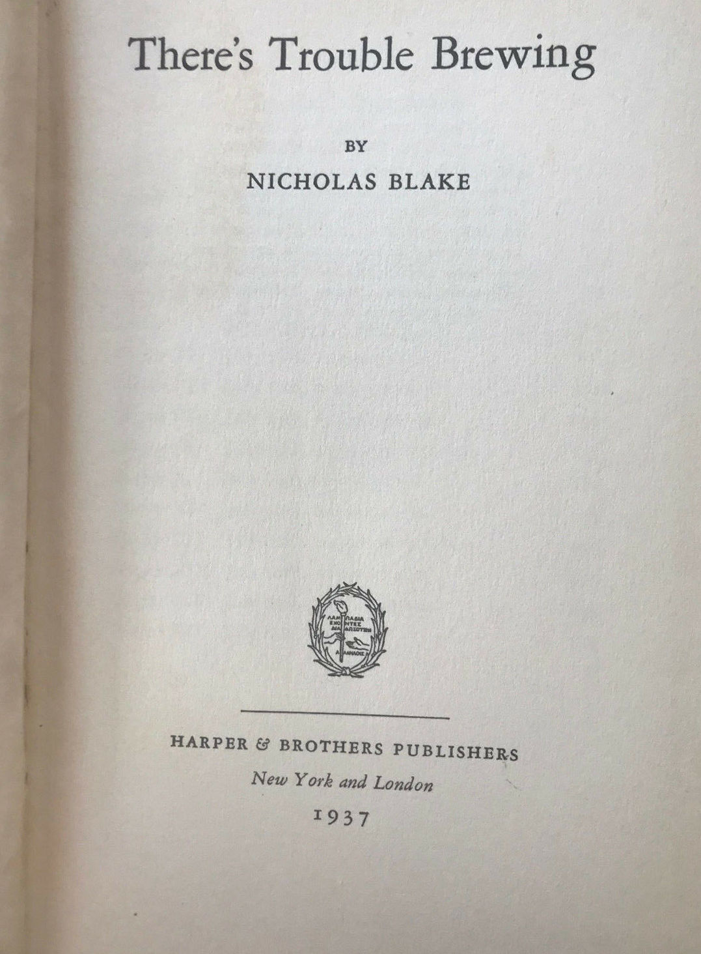

Blake, Nicholas
There’s trouble brewing
Harper & Brothers (USA) (1937) first printing

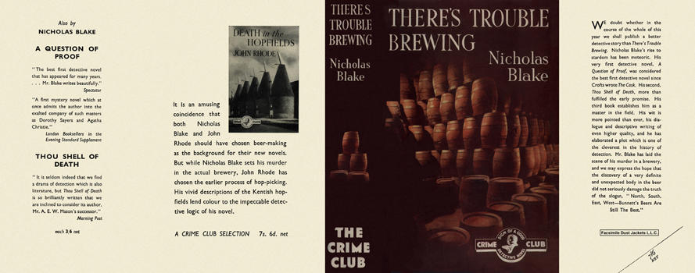

Blake, Nicholas
There’s trouble brewing
Collins The Crime Club (UK) (1937) first printing.

Суперобложки и внешний вид первых изданий книги

