

Biggers, Earl Derr
Keeper of the keys
Grosset & Dunlap (USA) (1932)

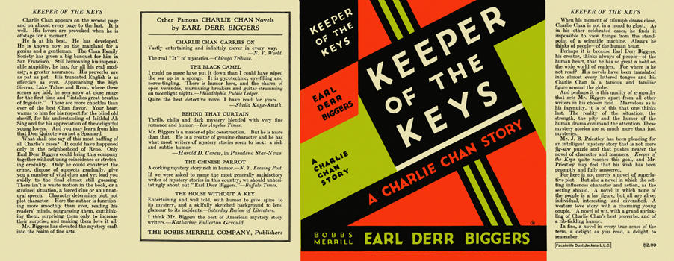



Biggers, Earl Derr
Keeper of the keys
The Bobbs-Merrill Company (USA) (1932) first printing


Biggers, Earl Derr
Keeper of the keys
Toronto: McClelland and Stewart, 1932

Суперобложки и внешний вид первых изданий романа

