

Biggers, Earl Derr

Behind that curtain
The Bobbs-Merrill Company (USA) (1928) first printing

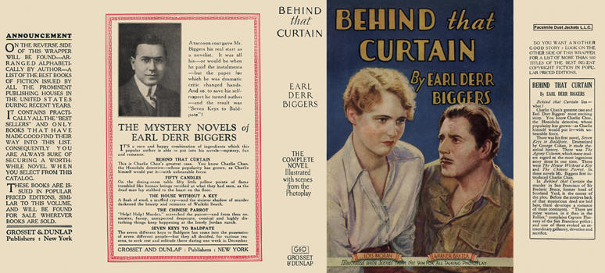

Biggers, Earl Derr

Behind that curtain
Grosset and Dunlap (USA) (1928)

Суперобложки первых изданий романа

