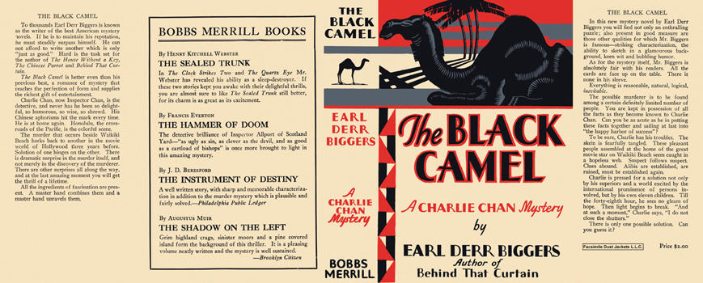

Biggers, Earl Derr
The black camel
The Bobbs-Merrill Company (USA) (1929)
first printing.

