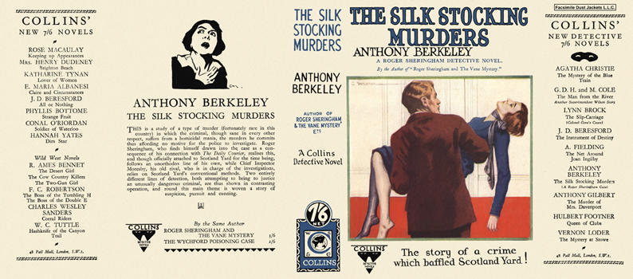



Berkeley, Anthony
The silk stocking murders
Collins Detective Novel (UK) (1928) first printing



Berkeley, Anthony
The silk stocking murders
Doubleday The Crime Club (USA) (1928) first printing

Внешний вид первых изданий книги

