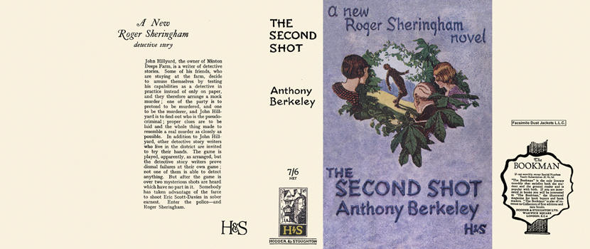

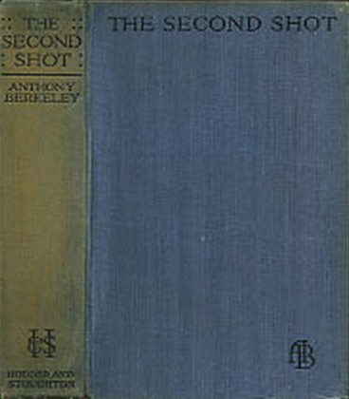

Berkeley, Anthony
The second shot
Hodder and Stoughton (UK) (1930) first printing

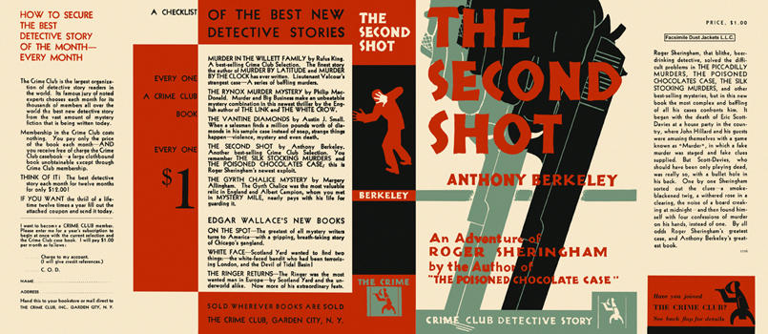

Berkeley, Anthony
The second shot
Doubleday The Crime Club (USA) (1931) first printing

Внешний вид первых изданий книги

