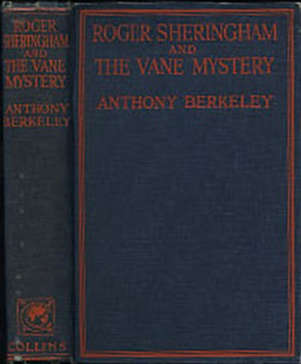

Anthony Berkeley
Roger Sheringham and the Vane mystery
London: Collins, 1927. First edition

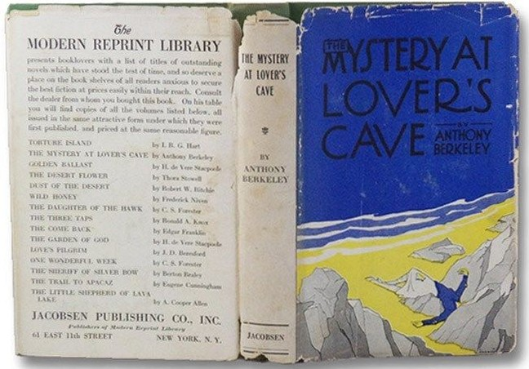
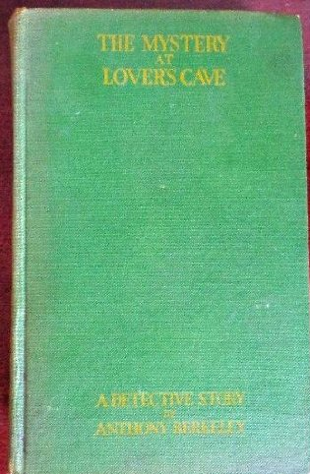

Anthony Berkeley
The mystery at lover’s cave
New York: Jacobsen Publishing Company Inc., 1927

Внешний вид первых изданий книги

